ICT WEBSITE REPORT

Dogebee Earphone Store

TABLE OF CONTENTS

Introduction

Website Structure

Website Layout

Preparation of multimedia (logo, banner, animation/video) 未搞

Implementation of Home page and Product page

General

Products Page

Individual product page 未搞好

Overview of Registration and Login page

Users Account Database Structure + whole database structure 未搞

User Account Management

Order history

Admin Functions [admin.php]

Adding new product [admin_add.php & admin_add_submit.php]

Admin Orders Management [admin_orders.php]

Checkout function in cart.php

Navigation Bar Product Seach function [search.php]

Special Features

Website Consistency 未搞

Language switch未搞

Comparing products未搞

Customers comments未搞

Introduction:

This is a Hi-fi webstore.

Providing a test soundtrack, which is from online recordings with a human-like headset wearing the headphones from the product catalog, although the actual feeling (feel of listening) will not be the same as the reality, but it is just for a reference.

The additional function:

There is a page used for choosing different tones, which is an audition room, there is an amplifier setup(decoration) in the middle of the room, which allows users to select different tones to listen to different styles of music they prefer.

Explain: a function to provide different tones for the user to choose, after the selection of those tones, they will be subdivided and ultimately will come out to a few models of headphones for the user to choose from that fits their style. Earphones recommended to the user are according to the three tuning styles of headset e.g. bright, flat, bass, etc.

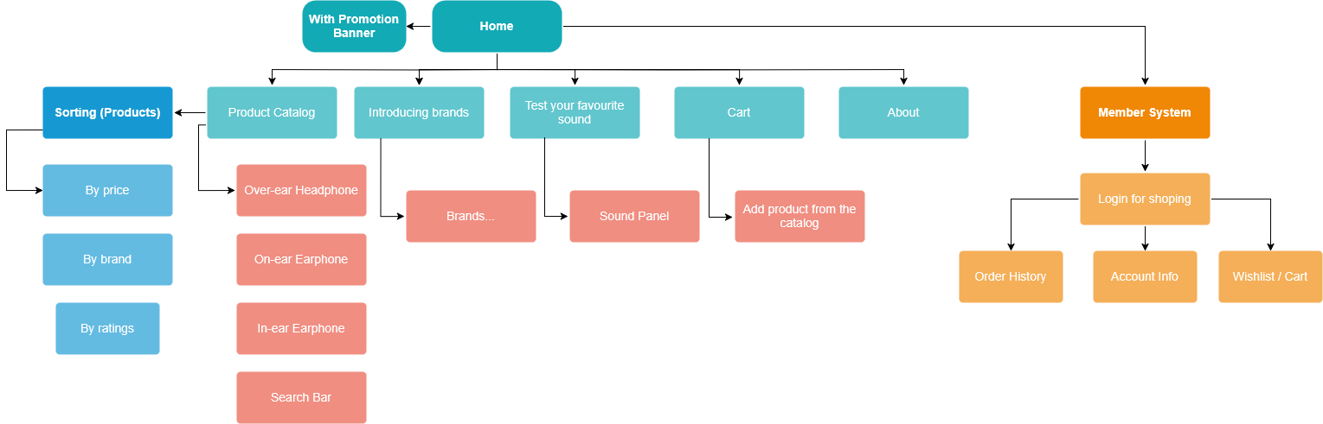Website Structure:

Website Layout:

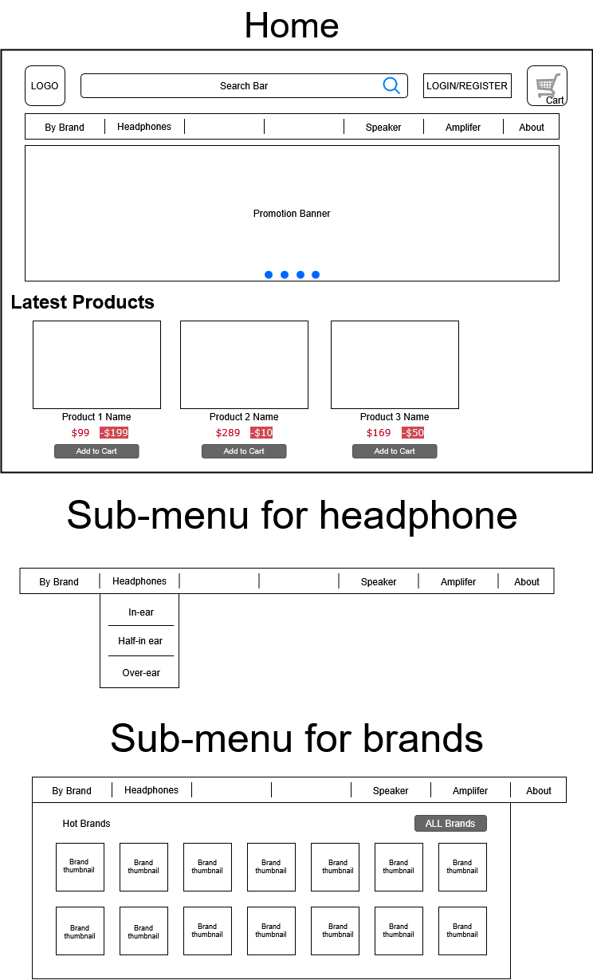



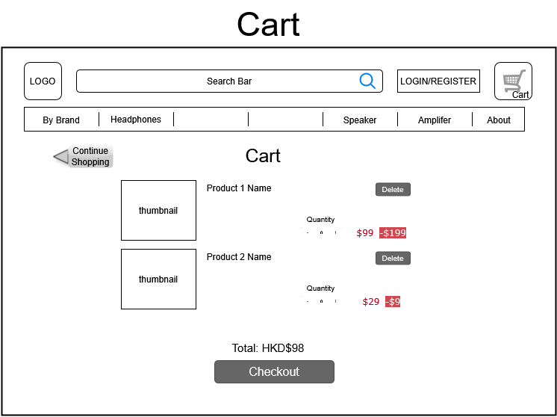

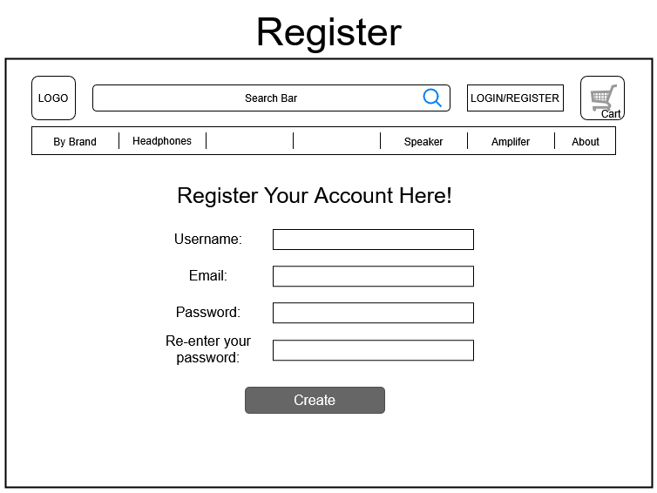

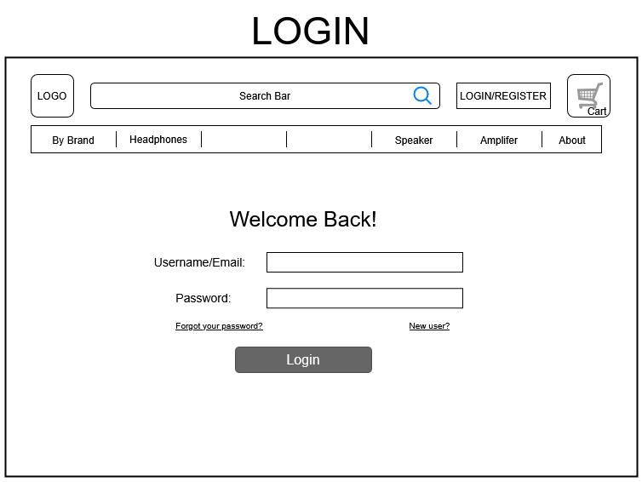

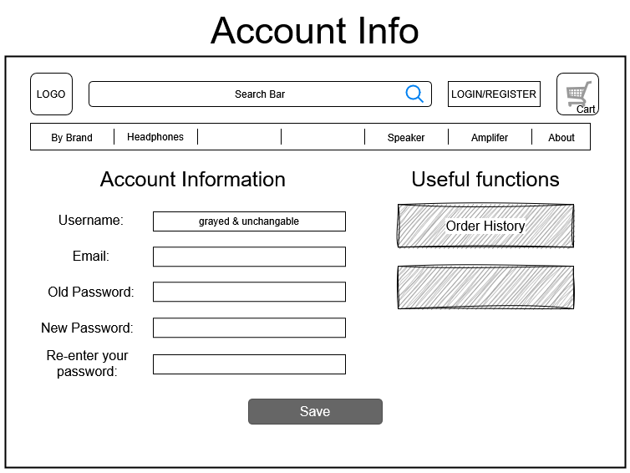

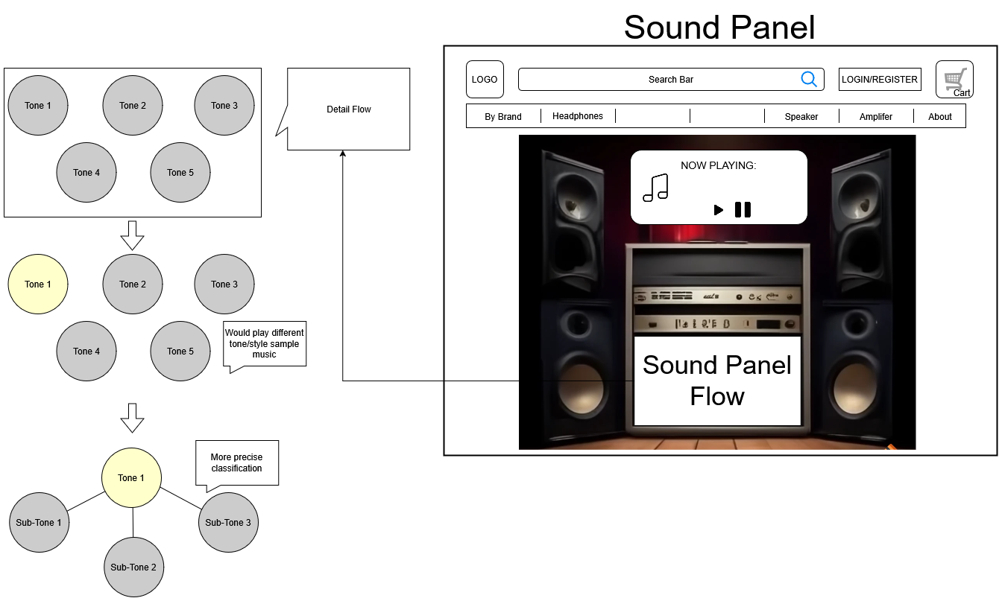

1. Preparation of multimedia (logo, banner, animation/video)
2. Implementation of Home page and Product page
3. General

The overview of the home page

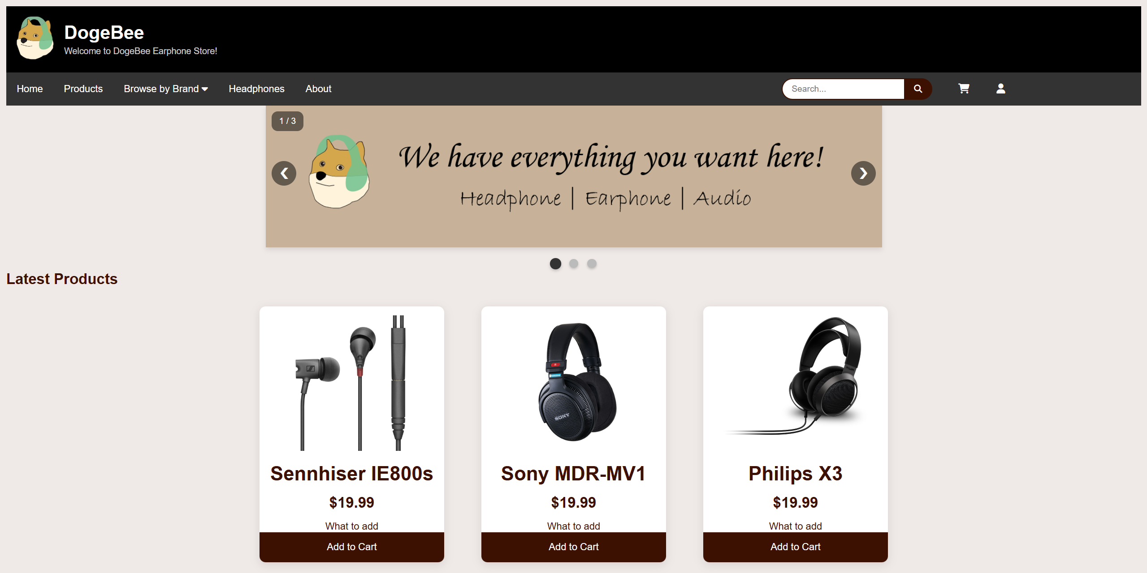

HTML (Header)

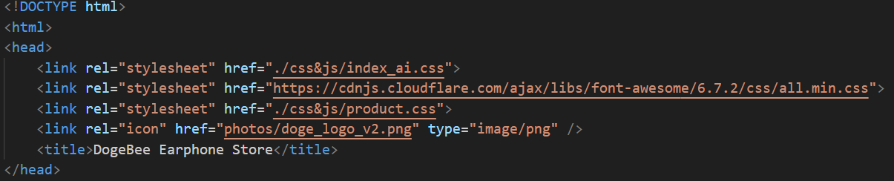

The following is included in the page inside the <head> element.

* The external stylesheet index_ai.css, all.min.css, product.css is linked in all pages with <link> element.
* The title for each page is included using the <title> element and the icon for the website is included using the <link> element. It will show as below:



Top of the navigation bar:

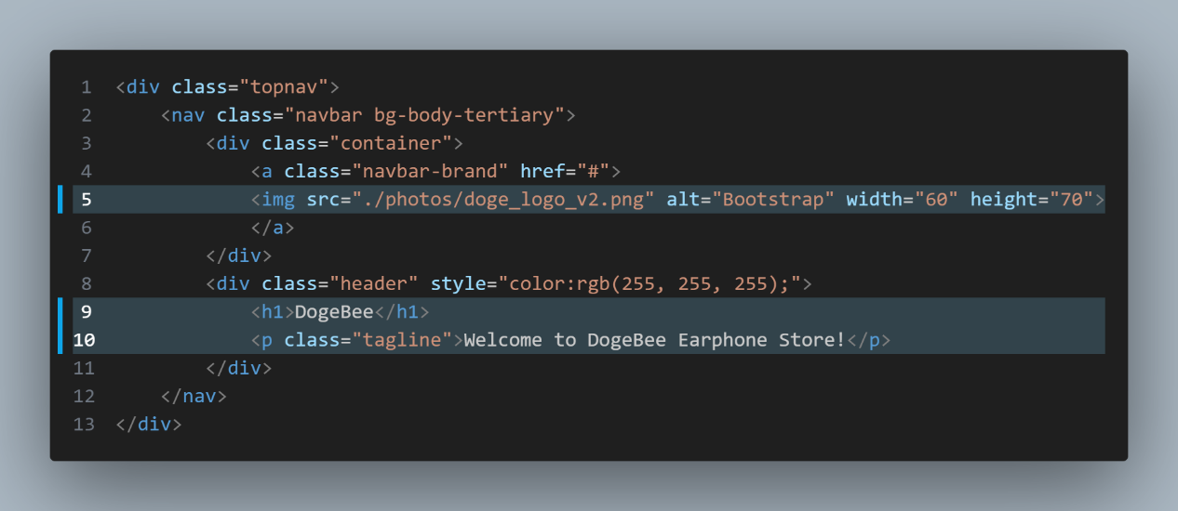

This allows the logo below to show by using <img src=”xxx.png”> pattern.

The <h1> and <p> are showing the store name and the welcoming sentence.

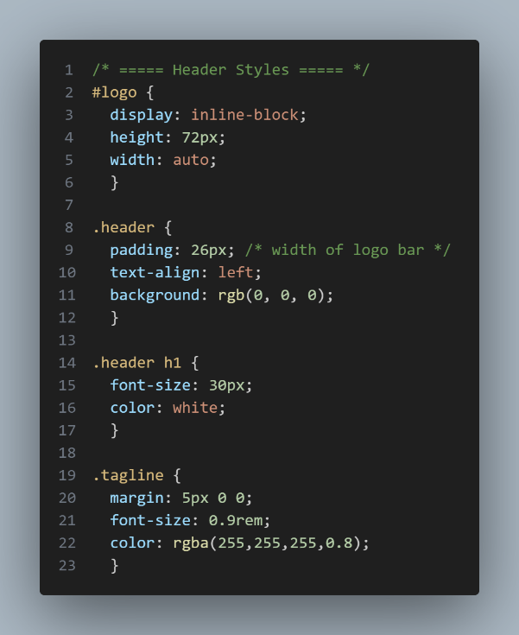CSS:

display: inline-block; does not add a line-break after the element, so the element can sit next to other elements.

It allows you to set width and height on the element, in the code it is set as height:72px; and width: auto;.

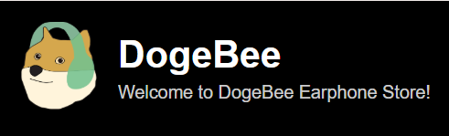

Effect:

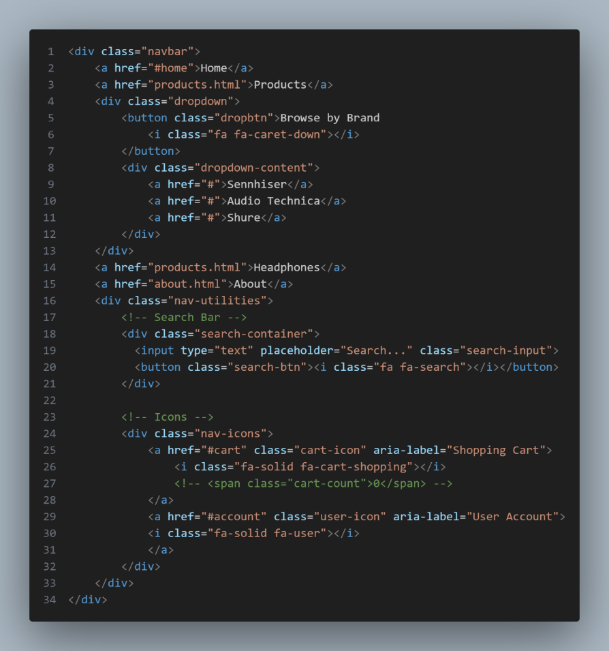HTML of Navigation Bar:

There are buttons for the Home page, products page, a dropdown list for browsing all the brands, a search bar, cart and user icon.

All the buttons are grouped by a CSS called search-container, it plays a part in aligning all the elements in a line.

Effect:



The dropdown menu of *Browse by Brand* button

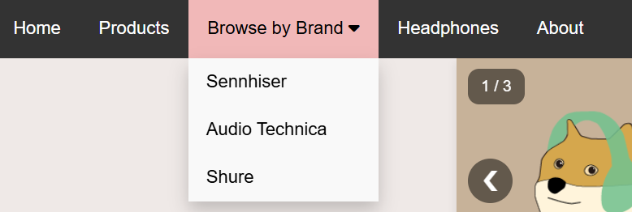

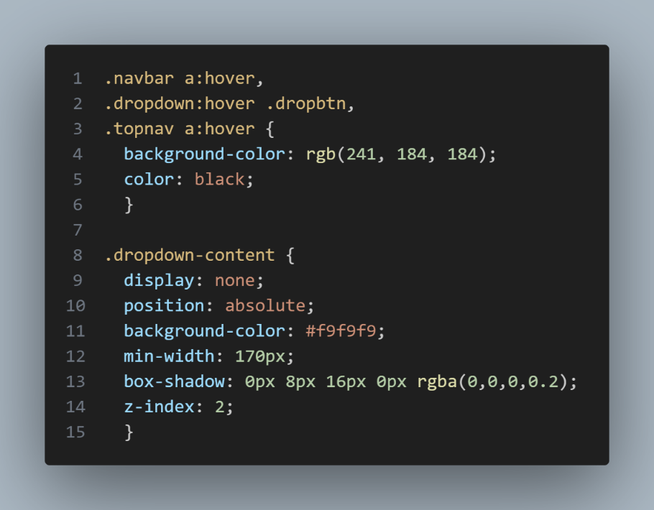CSS:

The buttons in navigation bar will change their text and background colour when the user hovers the curser shown as above.

The origianal text and background colour are white and dark grey respectively, the text and background colour changed to black and light pink after hovering.

Slideshow (by external JavaScript file; .js)

The variable slideIndex is to change the index of the slideshow (picture)

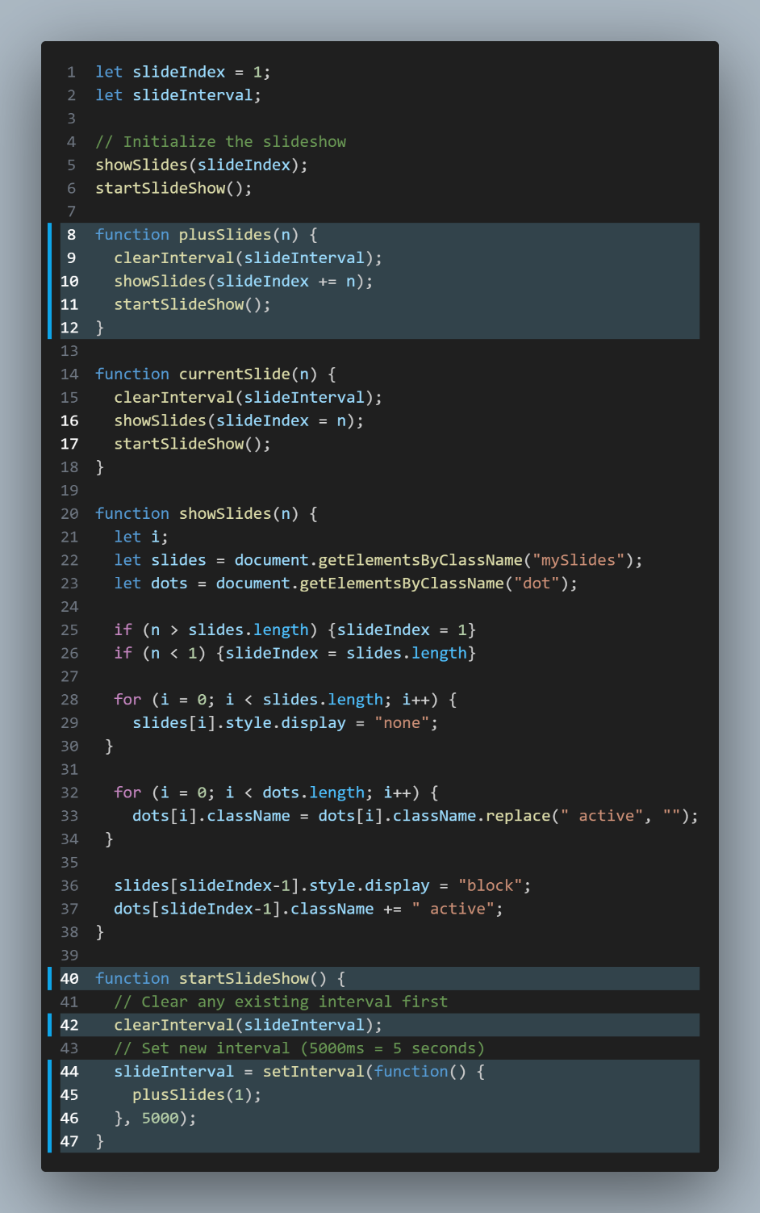

The startSlideShow() function is for calling the for loop to encounter the operation of slideshow. It changes the slideshow 5 seconds per slide, user can move the slideshow on their own too by the function plusSlides().

HTML: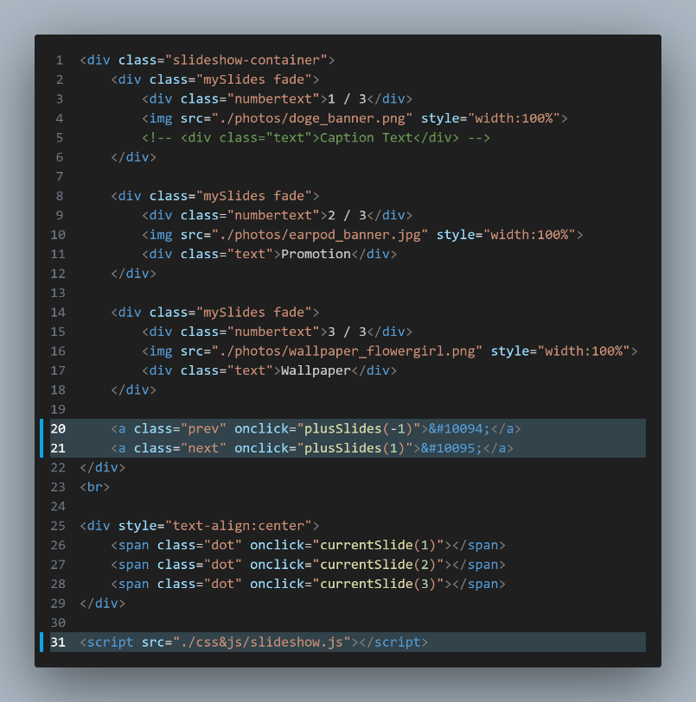

<script> </script> is to link to the javascript at the right side.

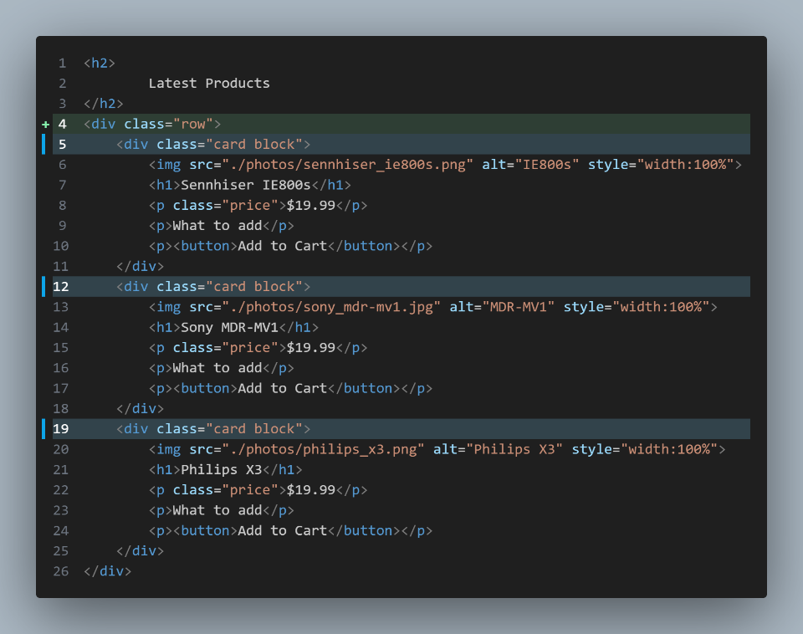HTML of product cards located at the latest product session:

The css .row is to group the product cards below in order to stay in a horizontal alignment, and the .block is to set the width of each product card.

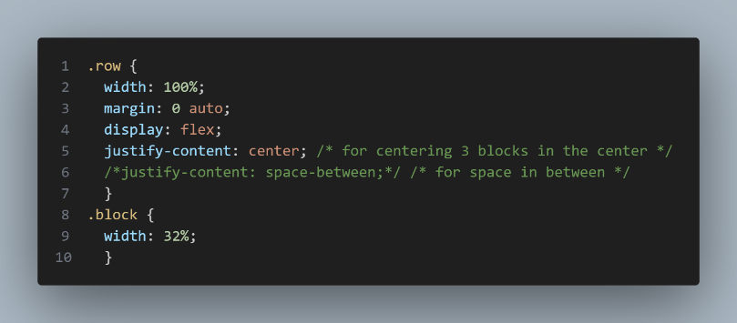

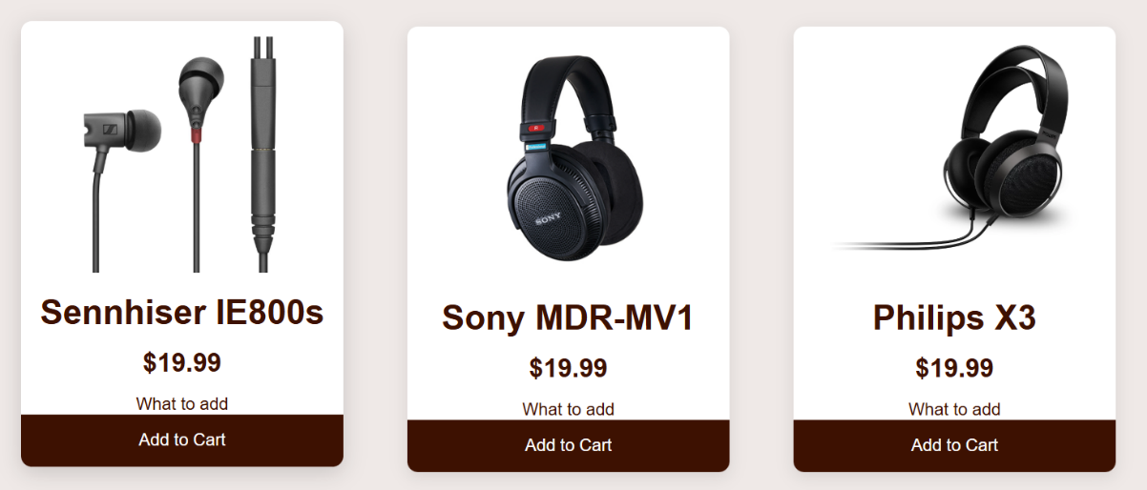The product card will shift up a bit and add a shadow effect when user hovers on it.

It is done by the css below.

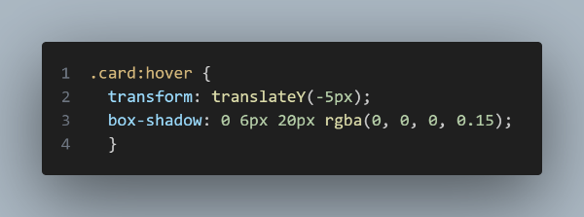

Products Page

Products filter:

This is the code of the products filtering side bar.

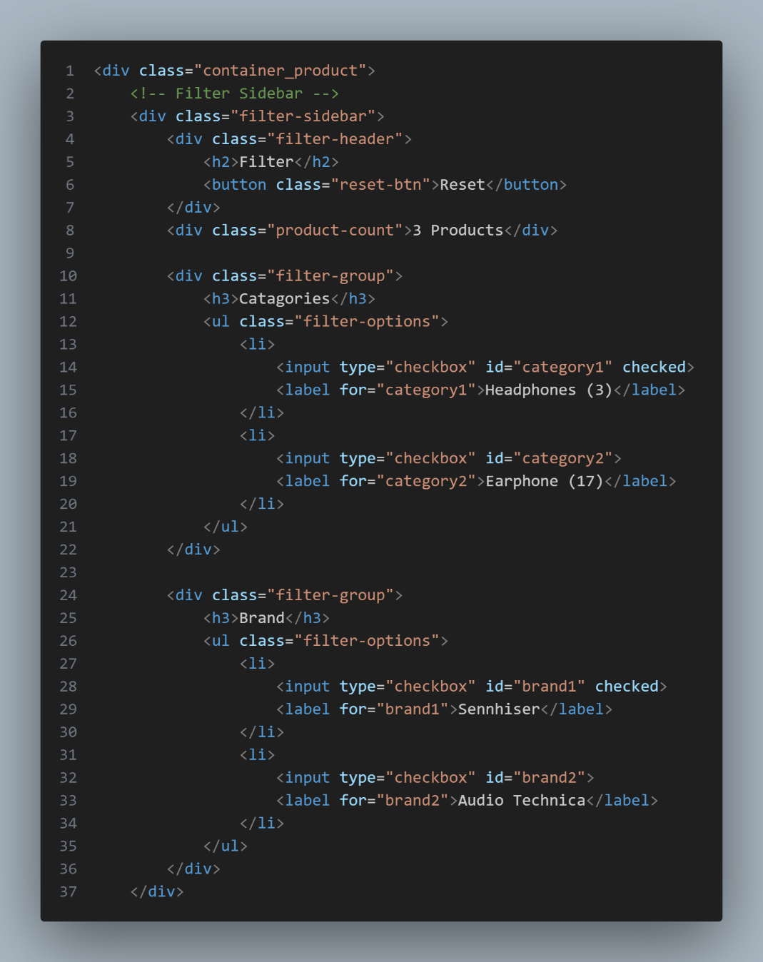

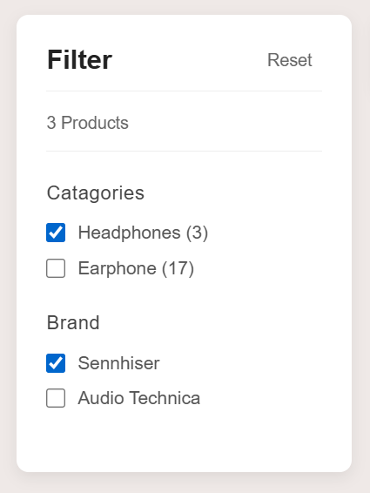Effect:

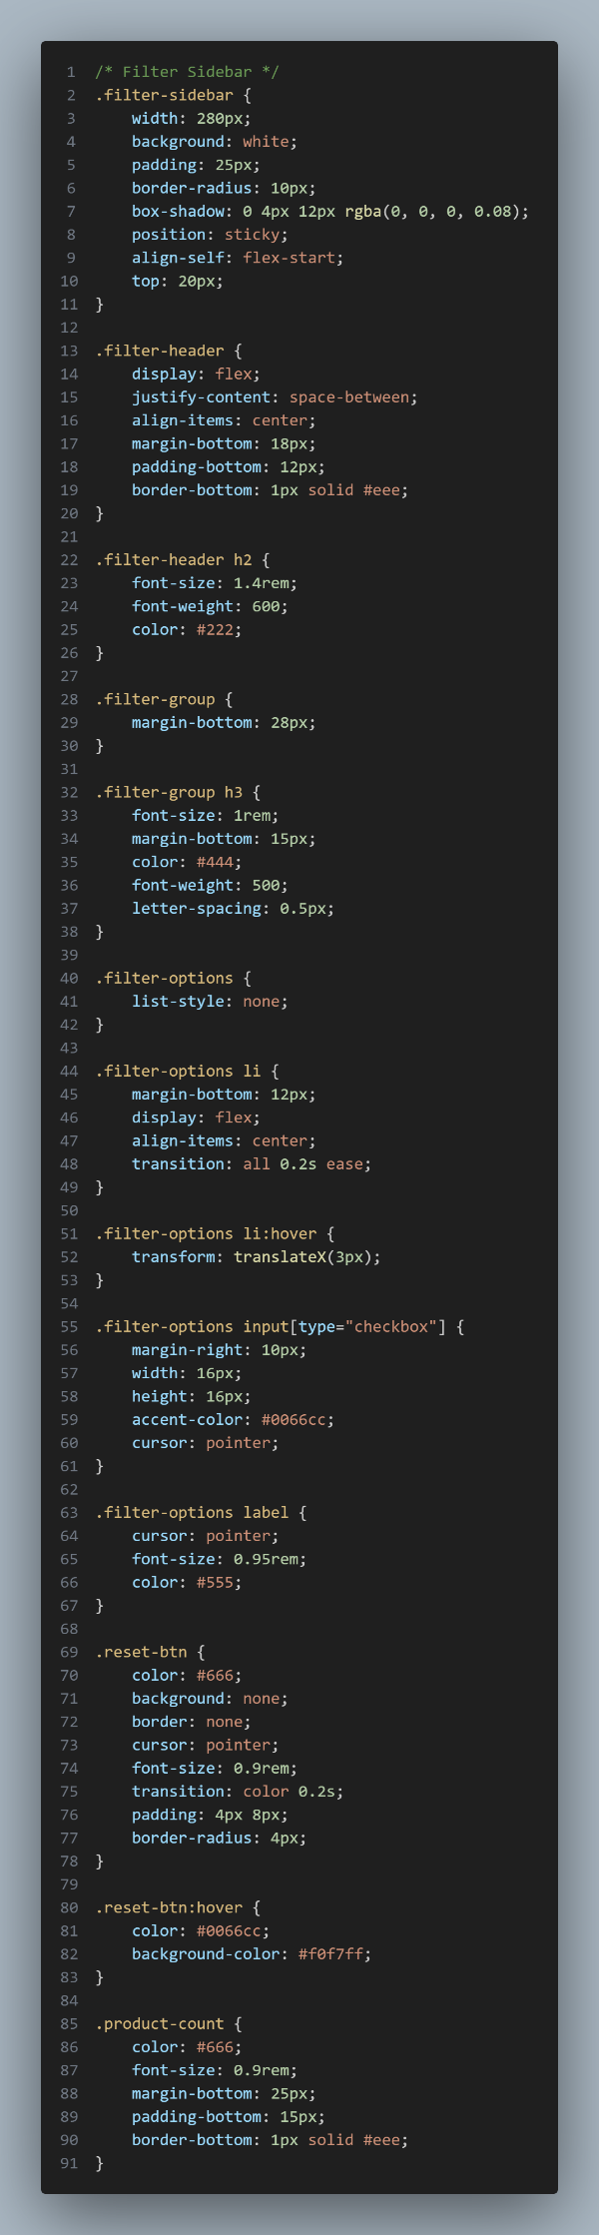Products Sorting:

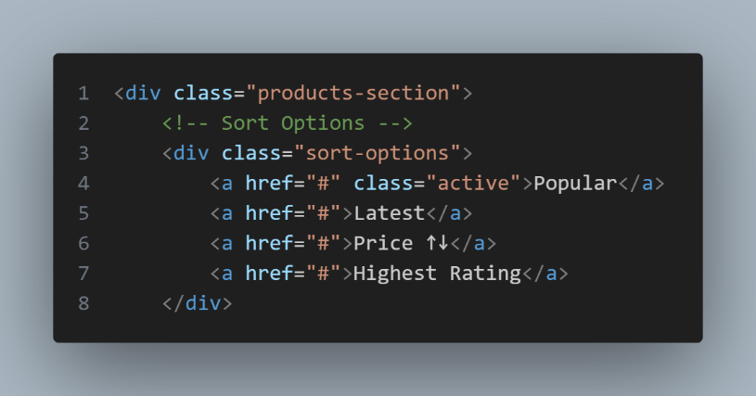HTML:

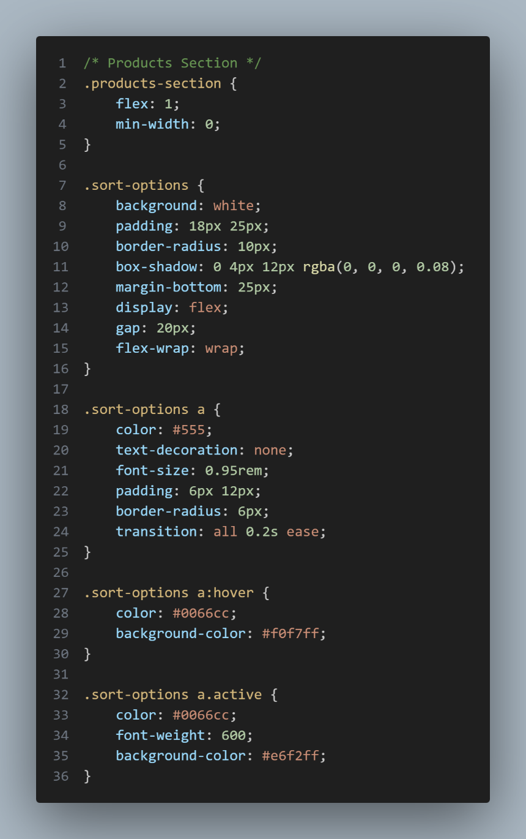CSS:

Effect:

Individual product page

The html of the product card ; When pressed, it would redirect to the individual product page

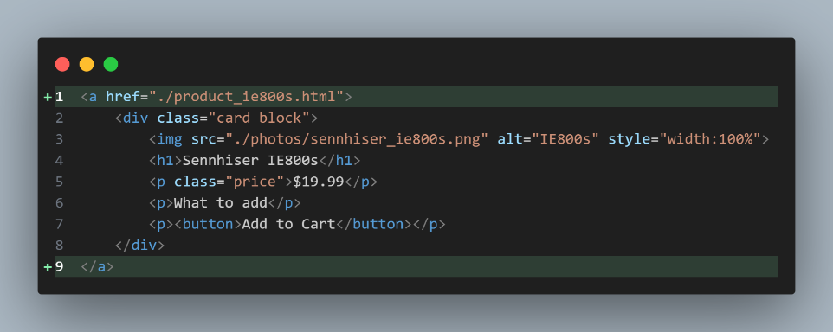

Overall effect:

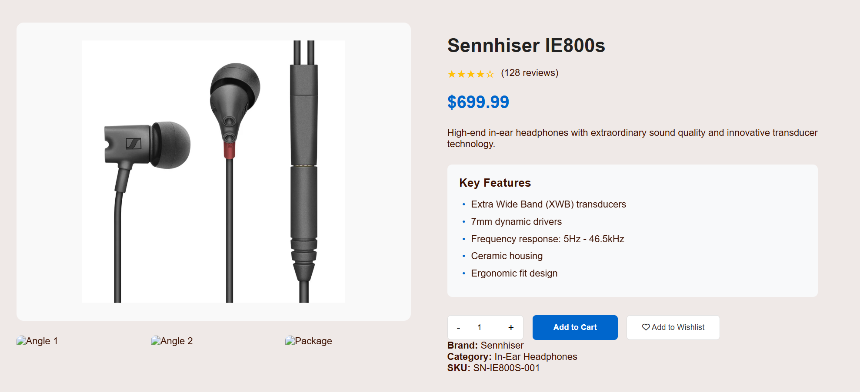

This function is not finished:

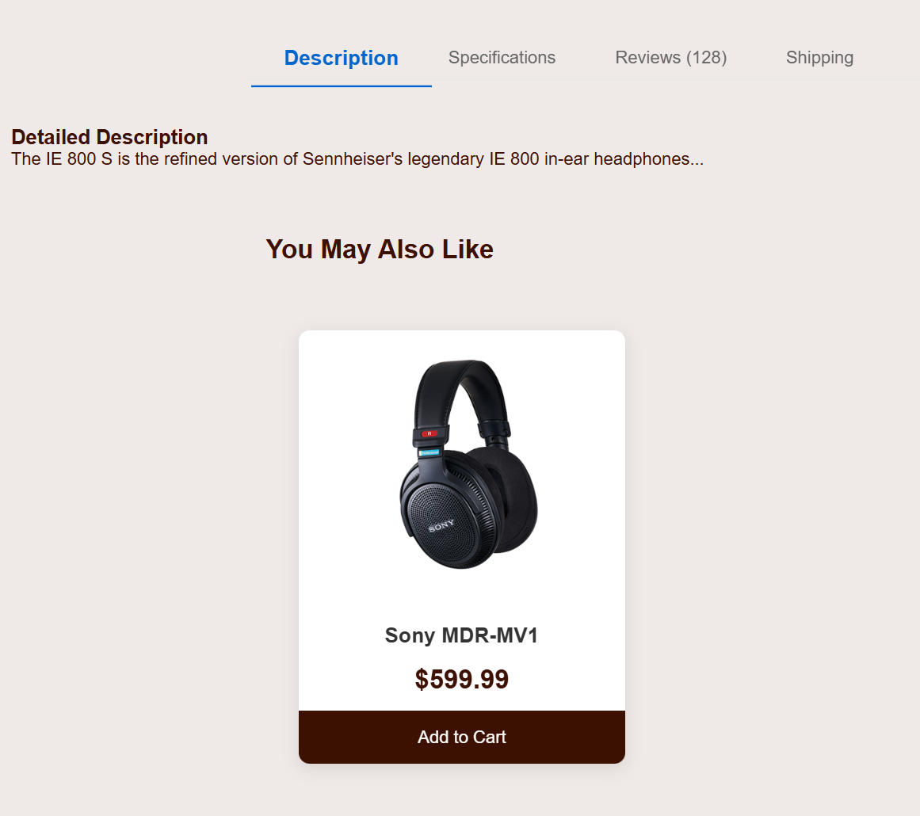

Javascript of quantity button of the product: 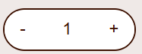

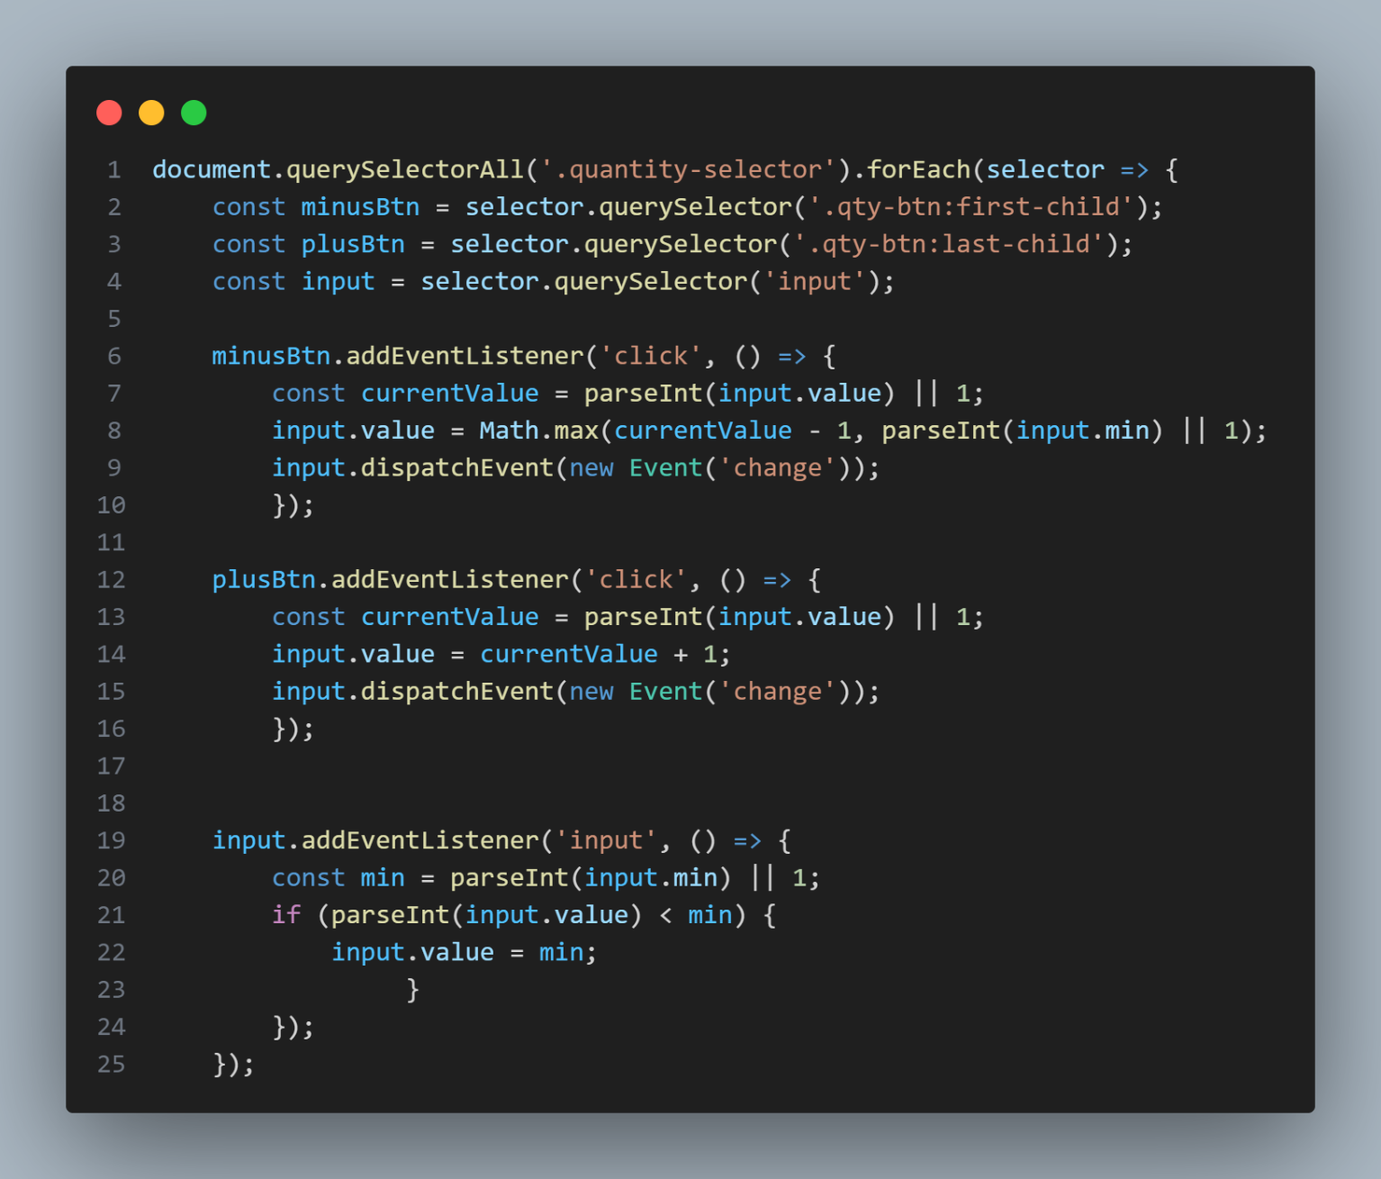

Overview of **Registration and Login page**:

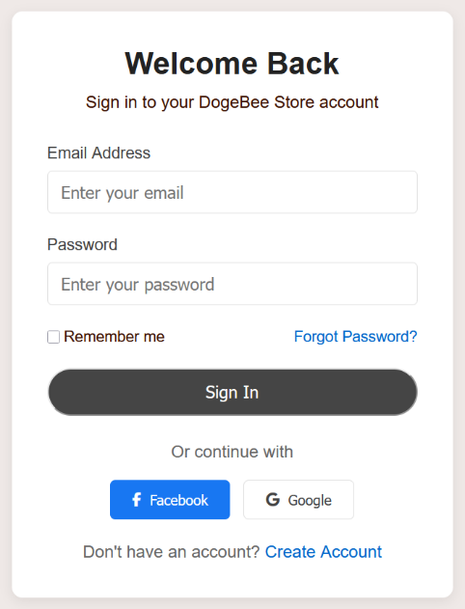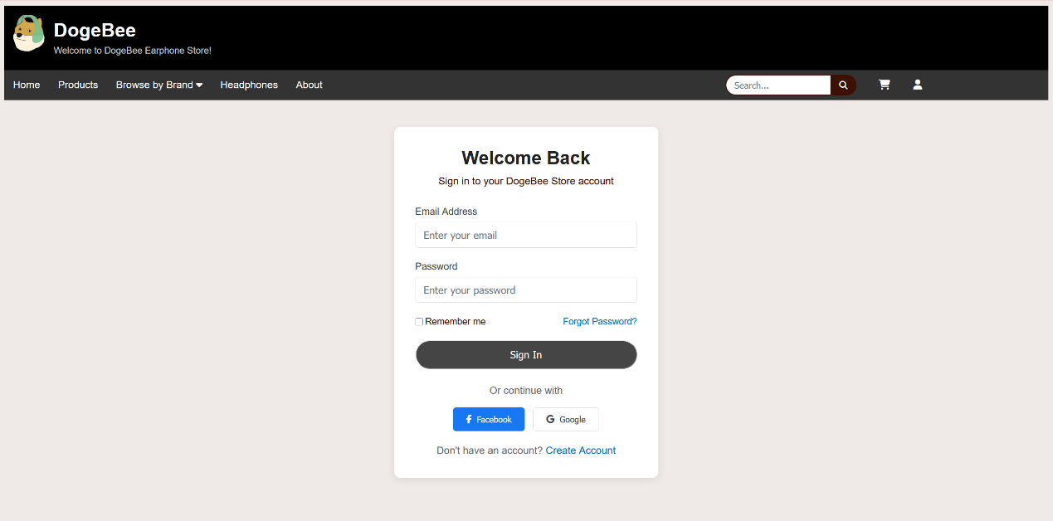

LOGIN: Register: 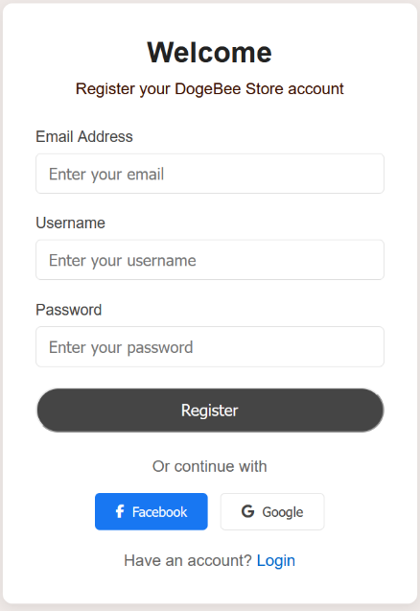

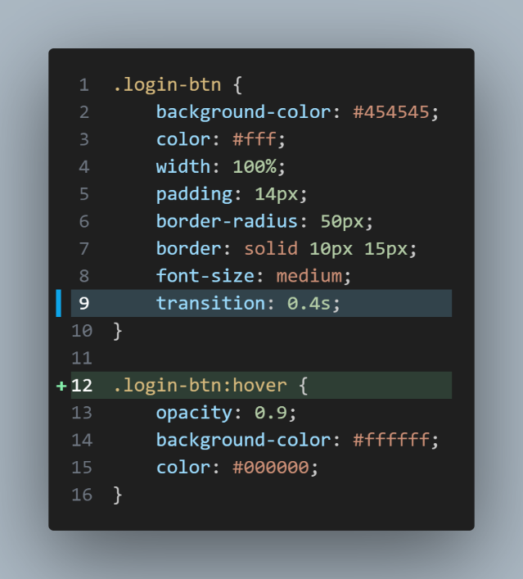Code:

The Sign in and register button contain a transaction when hovers on them.

The duration of the ransaction is 0.4s while the background colour turns white and the text colour turns black.

Overview of Login Page HTML:

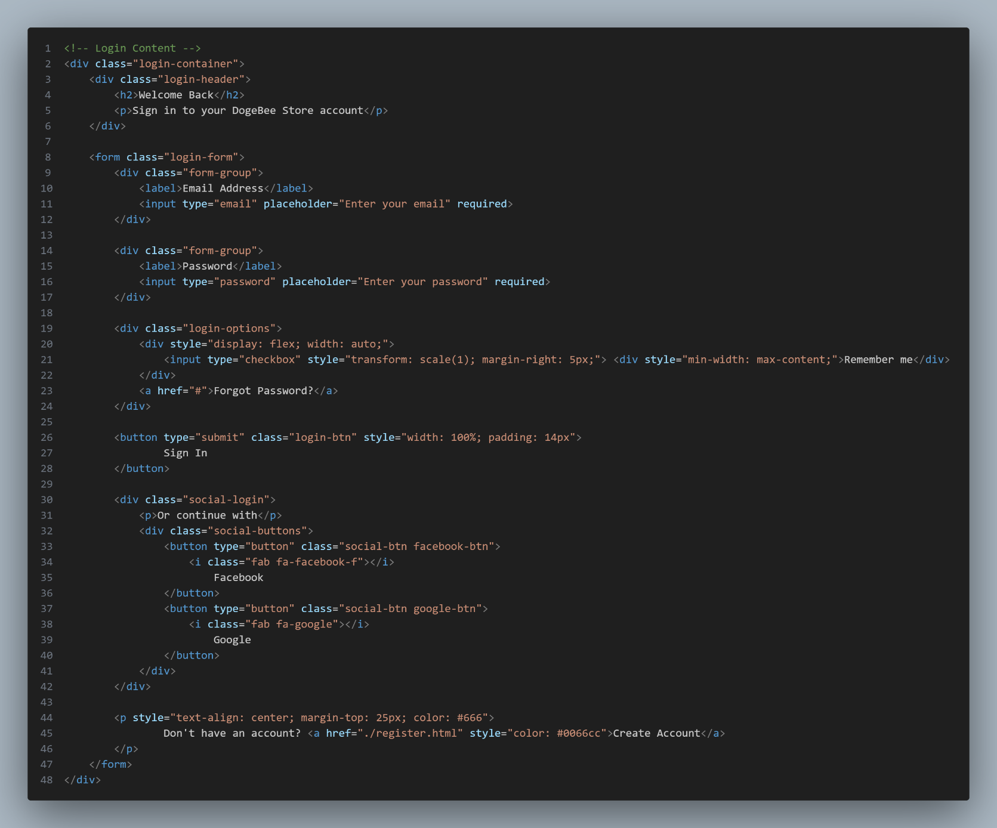

Users Account Database Structure: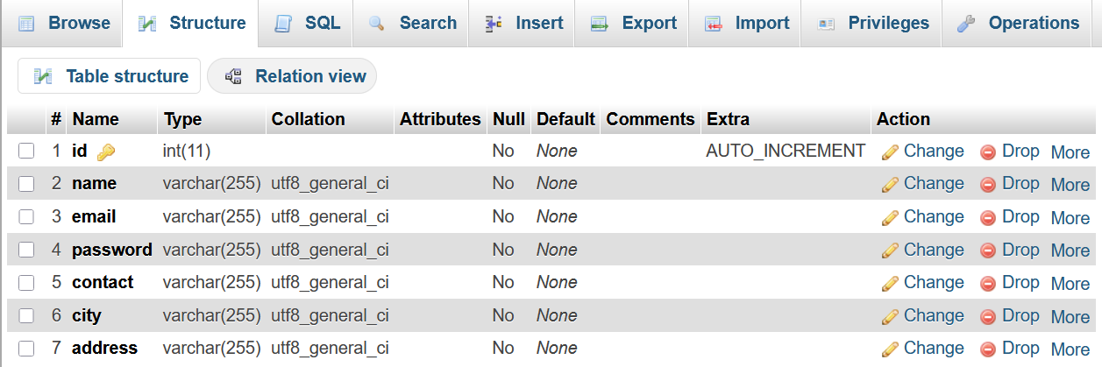

Example of an user data inserted in the database:

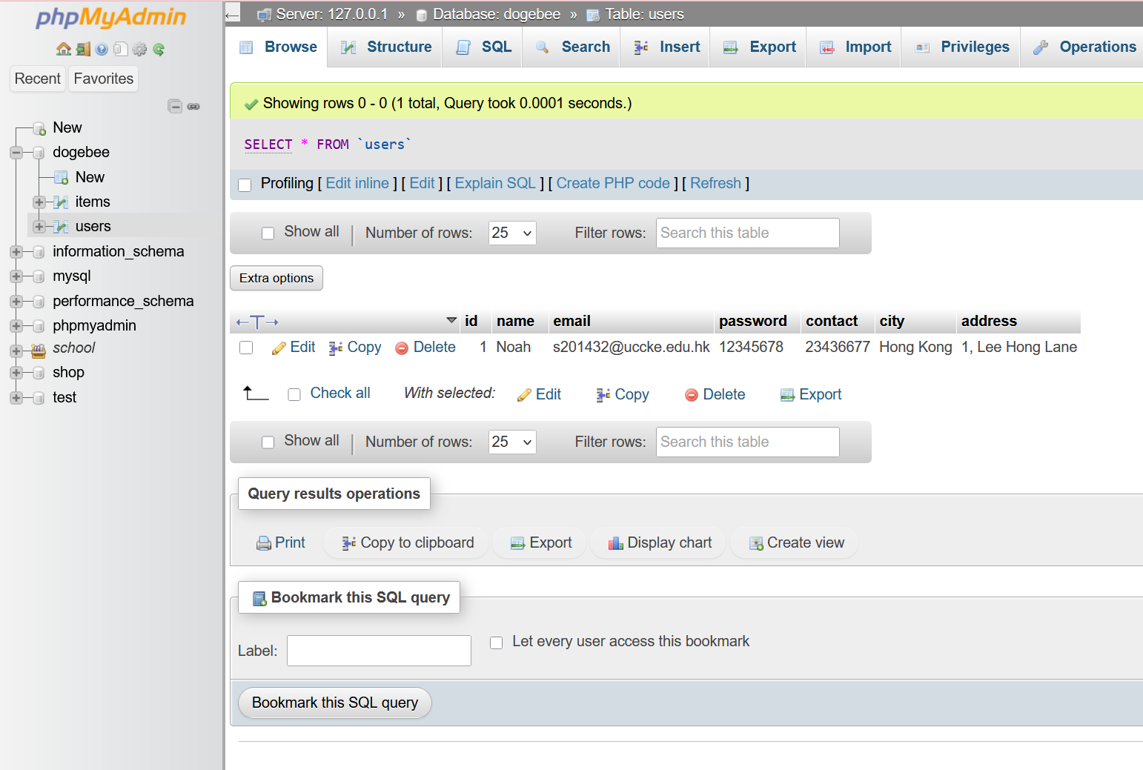

**User Account Management:**

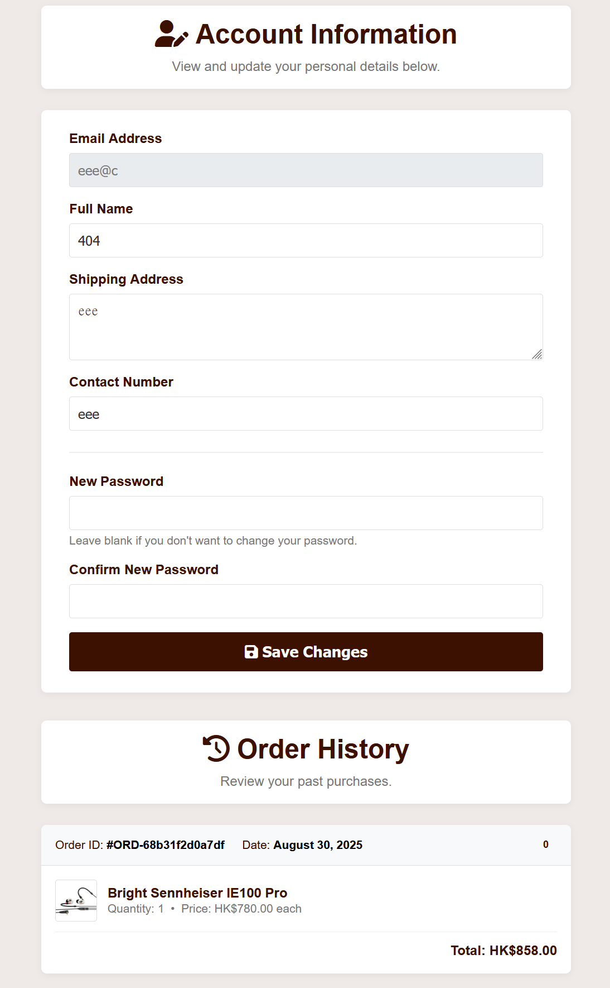 Effect:

The interface in 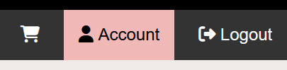navigation bar is in ‘account’.

Code: This php code is to enquire SQL query to the database in order to retrieve the account information.

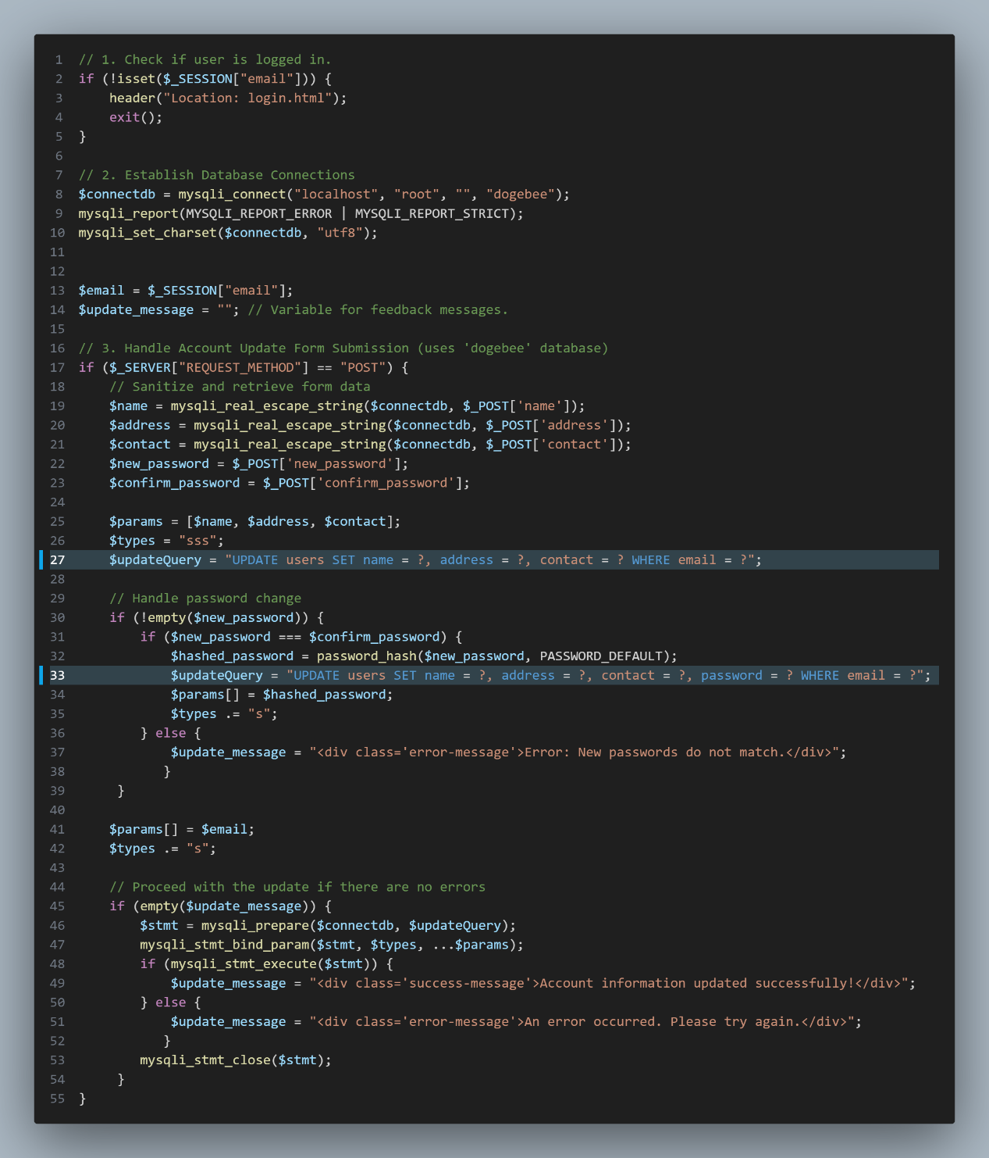

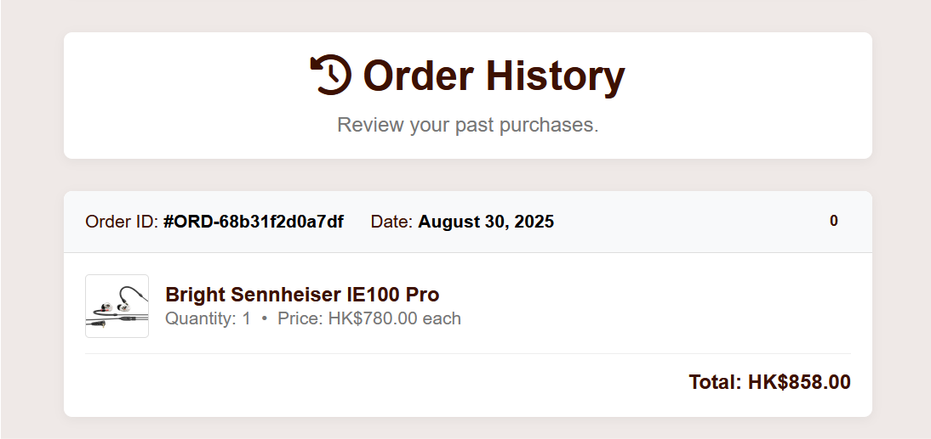**Order history:**

Effect:

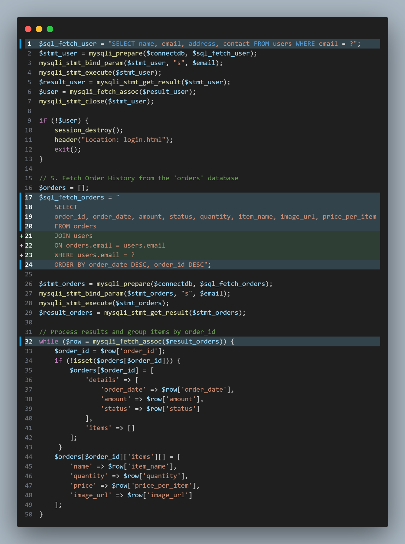Code: This is for retrieving orders information in ‘orders’ table while only selecting the current user’s email address

By using JOIN users ON orders.email = users.email WHERE users.email = ?

to join the users table

and connecting the email address from users to orders table.

The while function is to process the results fetched and group items by the order_id.

P.S. The order_id is generated randomly.

**Admin Functions [admin.php]:**

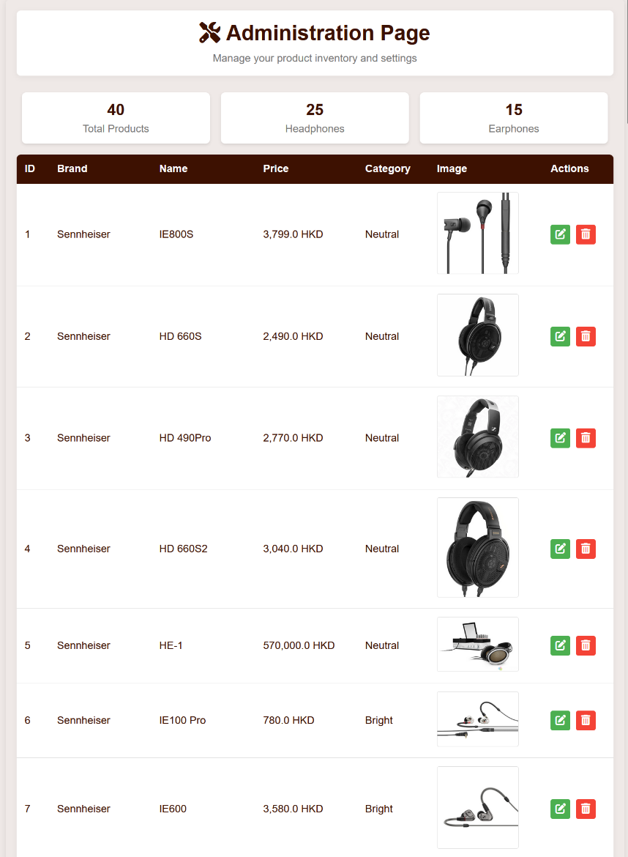Effect (Overview):

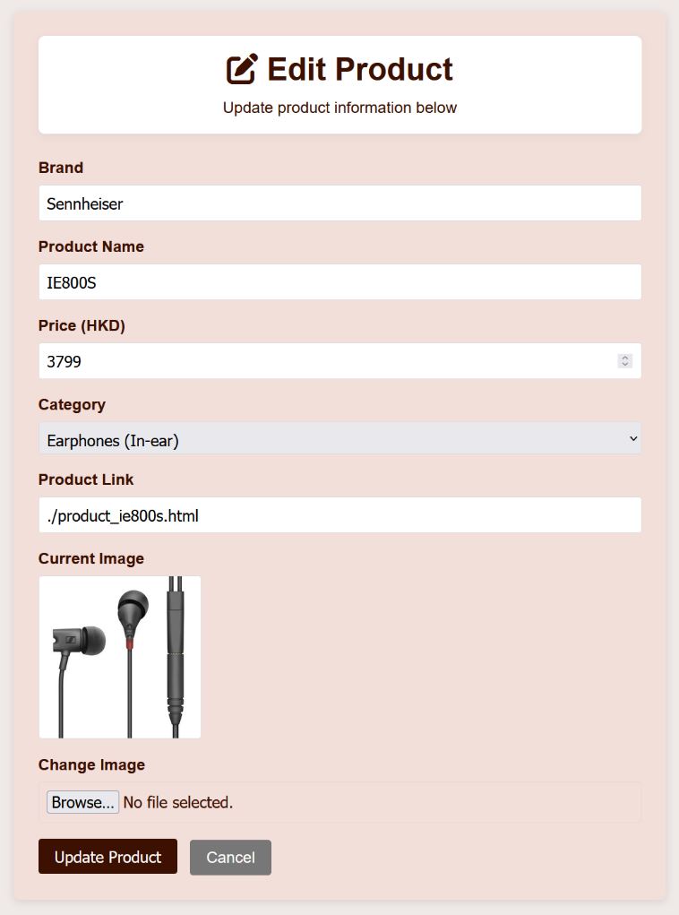Editing a product (Green button) [admin_edit.php]:

Code of fetching information from previous page i.e. admin.php and database:

The product ID is passed to admin_edit.php by GET method thereby set as the session product ID

There is a feature that if the product is not found on the database, it redirects back to the admin page.

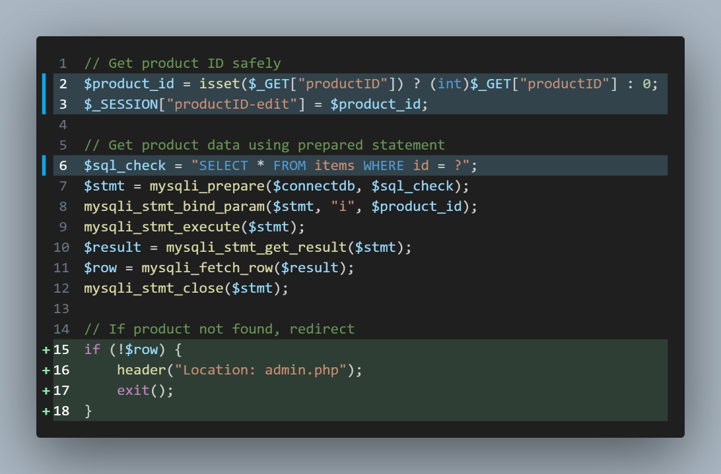

Input validation of admin_edit.php:

This javascript is to prevent misinput and unreasonable inputs being inputted to database.

i.e. The price must be greater than zero.

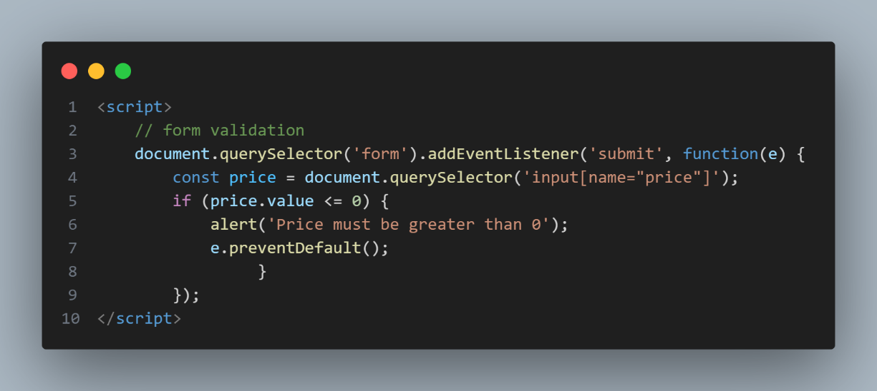

**Admin_edit_submit.php:**

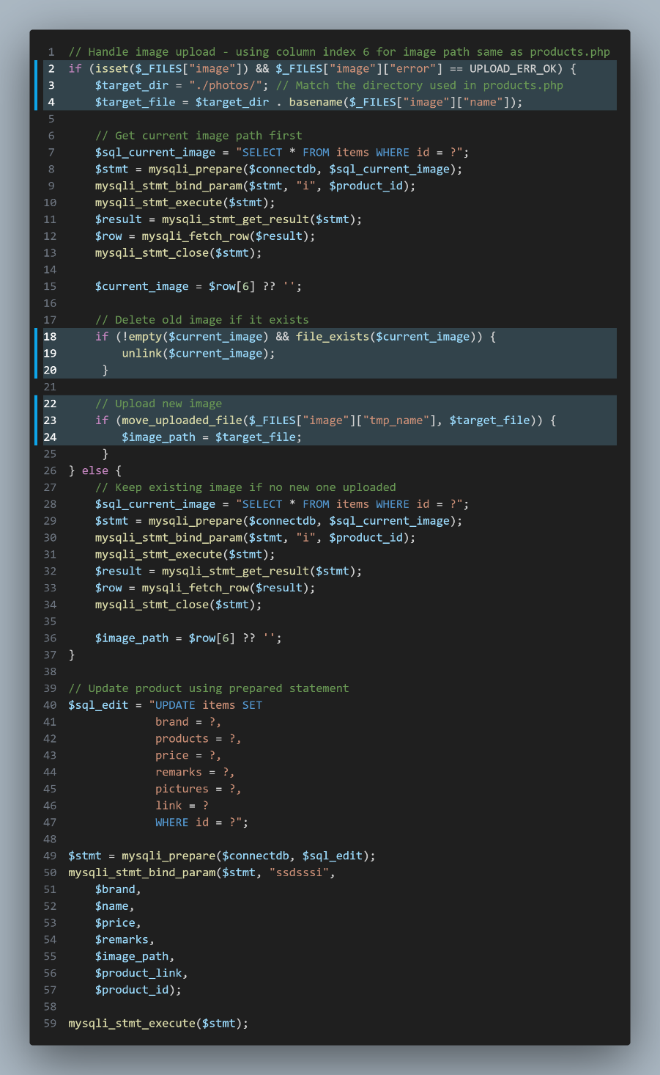This is for replacing the image URL of the old one and update it on database, and uploads the new product image to the server.

**Admin.php [product deletion]:**

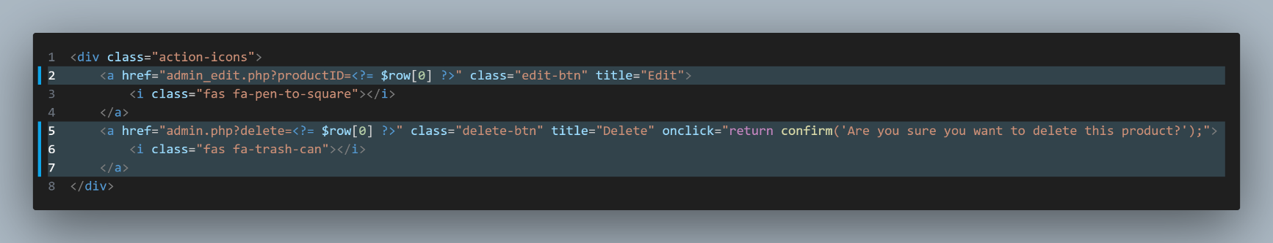

The GET request is passed to the code below:

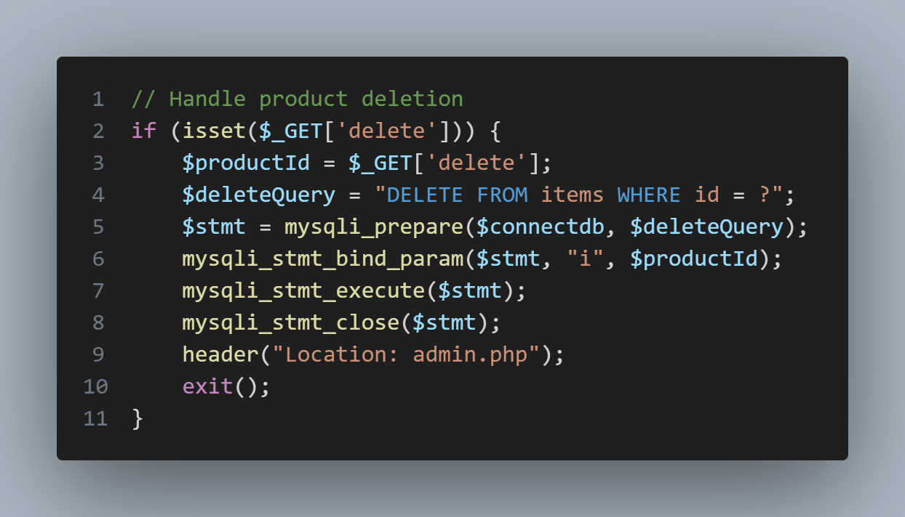

**Adding new product [admin_add.php & admin_add_submit.php]:**

Button from admin.php

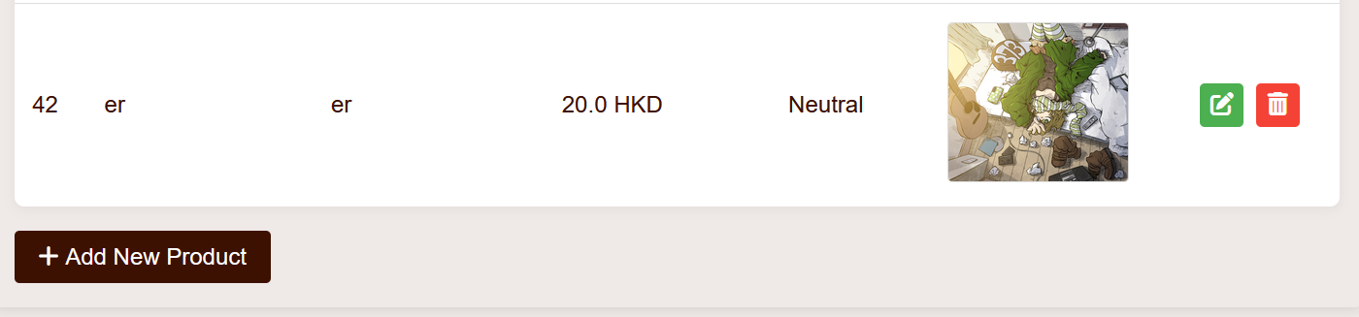

Effect:

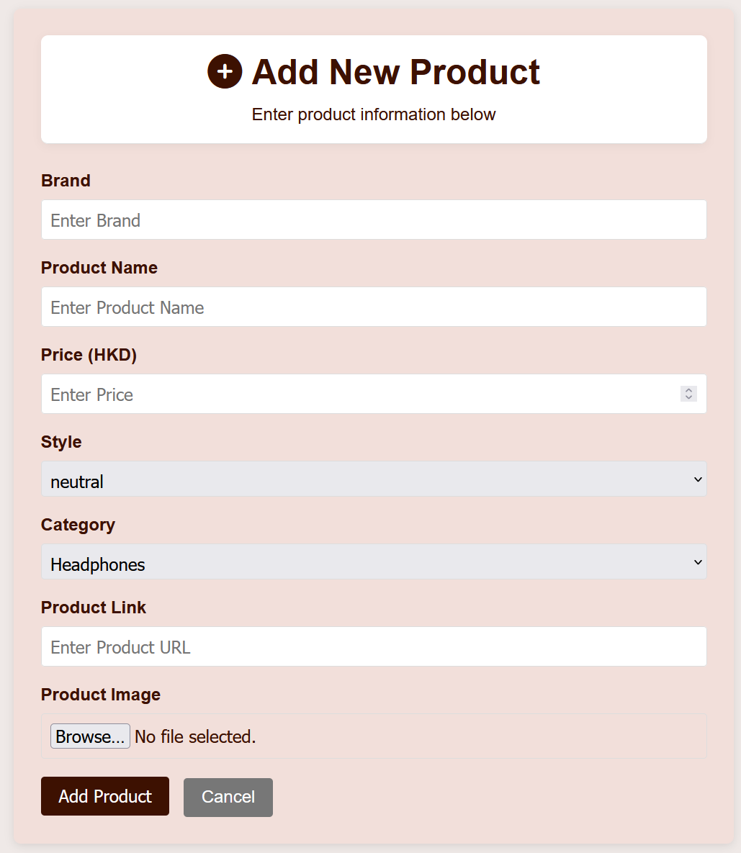

Code of admin_add_submit.php:

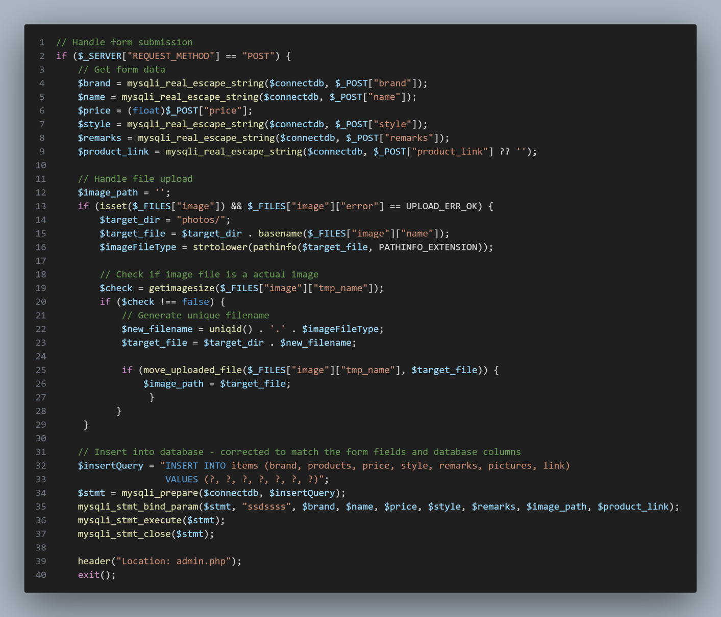

**Admin Orders Management [admin_orders.php]:**

Effect: 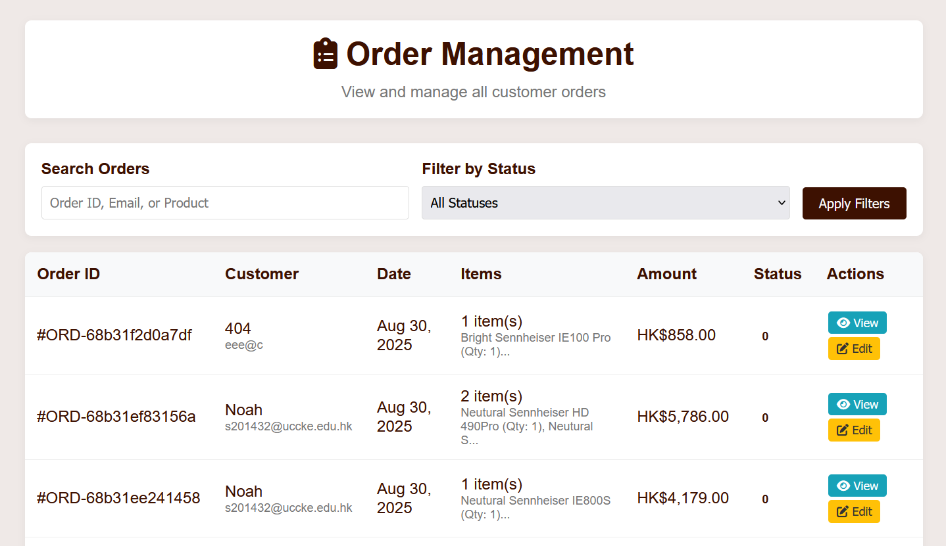

Code of fetching orders from the database:

There is a search for orders function which is done by the highlighted code below:

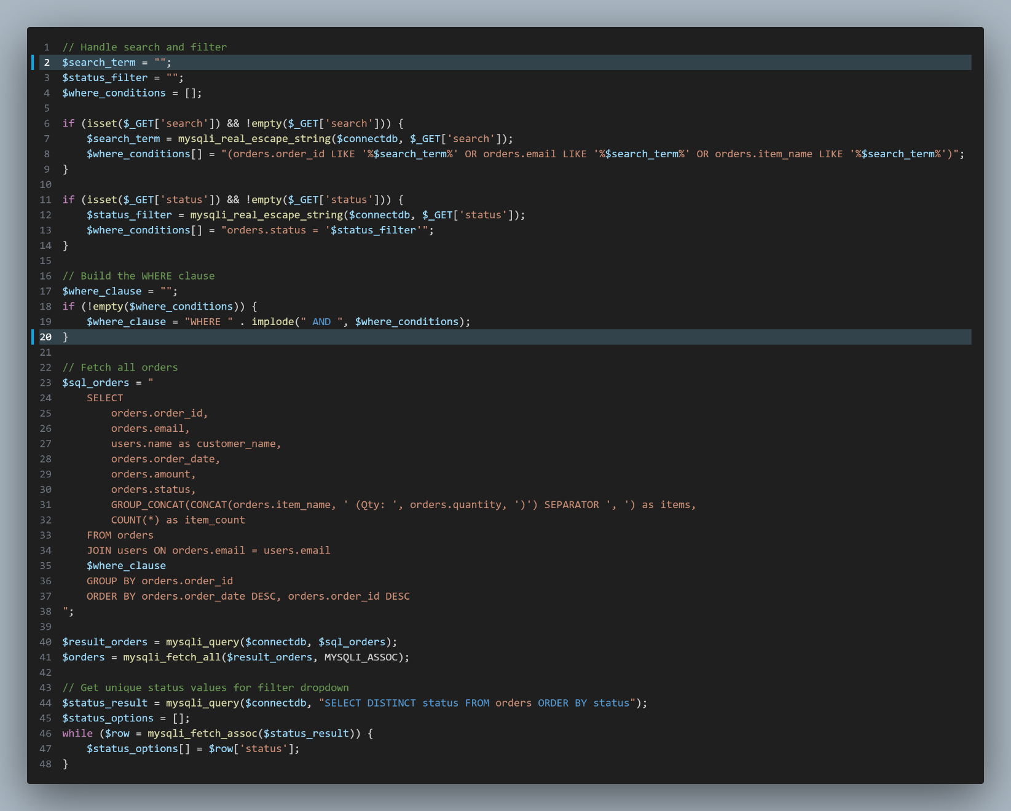

**Checkout function in cart.php:**

Effect; the second picture is the effect after pressing “Proceed to checkout” button:

Noted that the order_id is generated randomly.

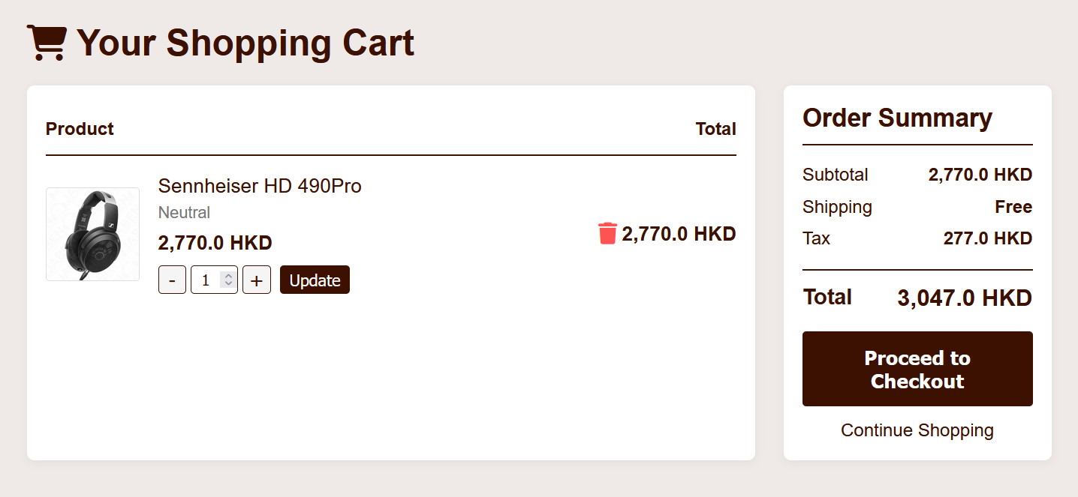

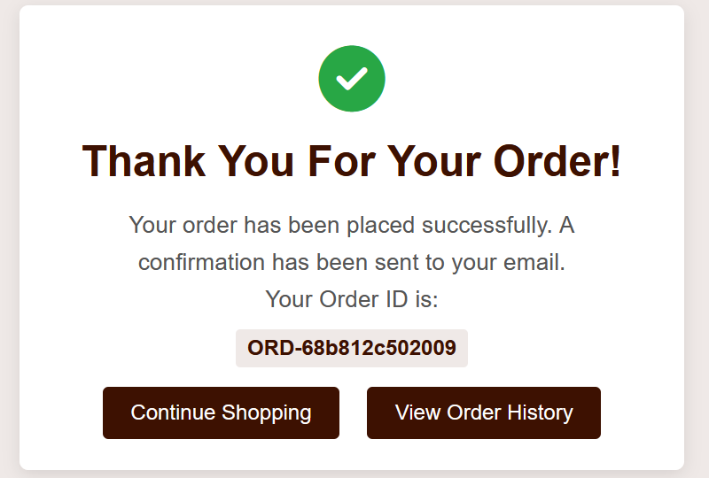

Pressing the “View Order History" button can be redirected to account.php:

The effect is shown below.

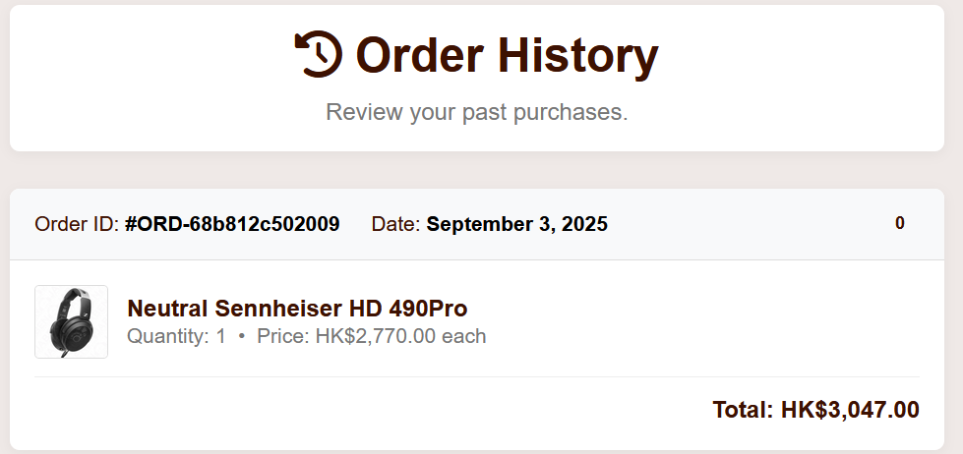

Code:

The order ID is generated randomly by the uniqid(‘ORD-’) function in line 16.

The order date is stored as the format of [Year-Month-Day Hour:Minute:Second] by using the date function in php in line 17.

The insert query to the orders database table of the order is located in line 21 to 23.

Eventually, we have to clear the shopping cart after checking out successfully so in line 53, we are using the unset function in the session to clear the cart history.

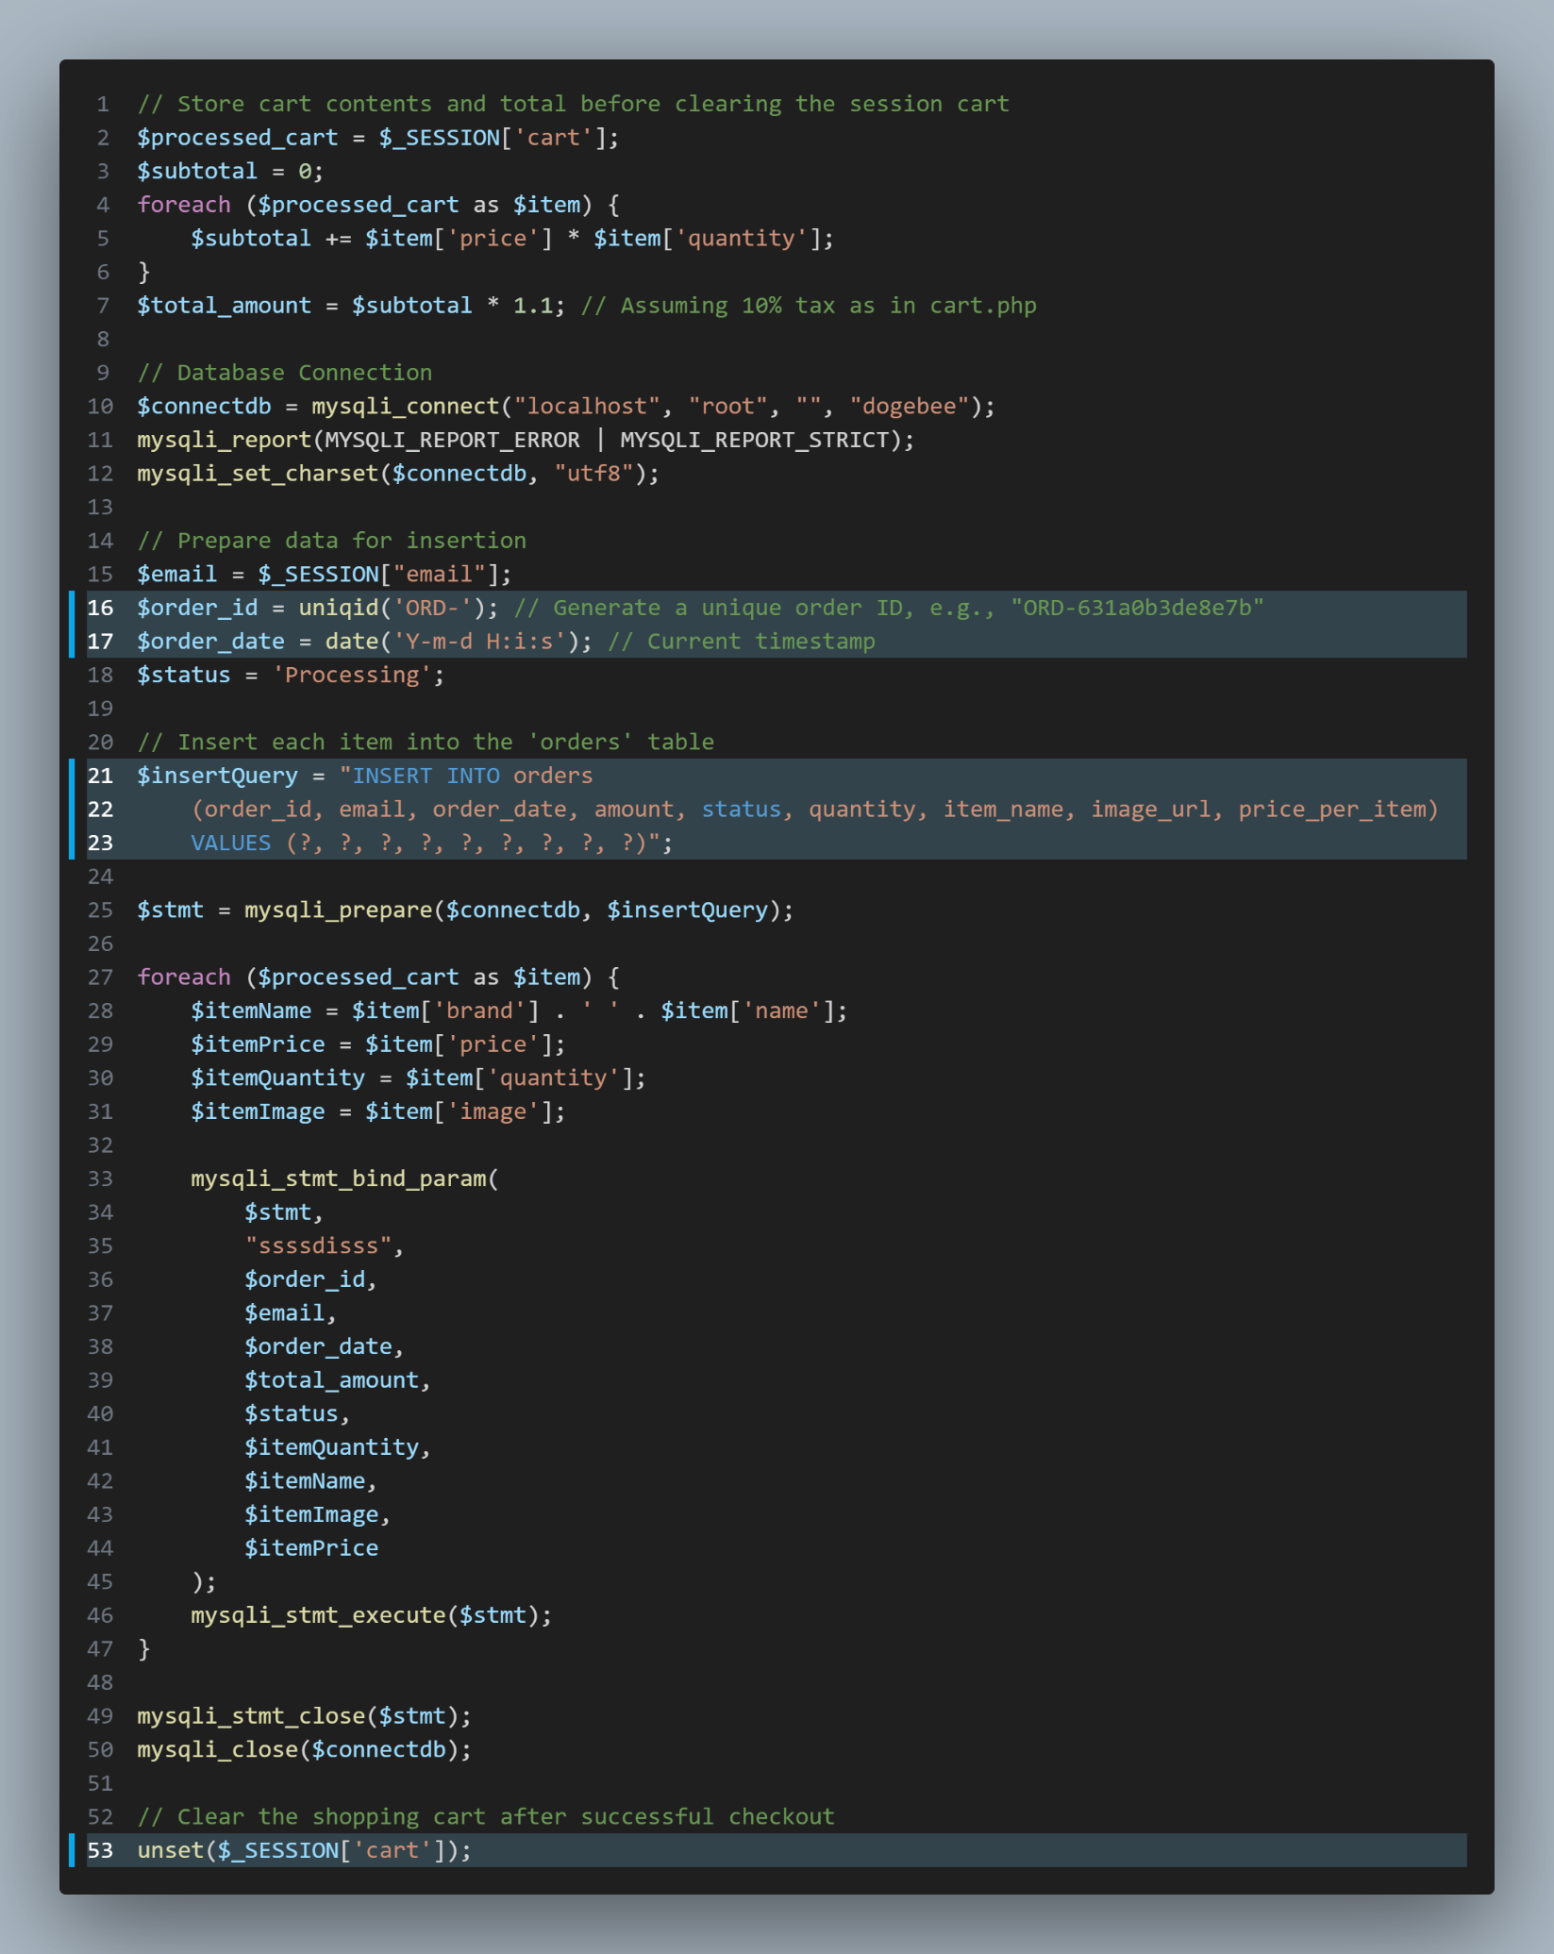

**Navigation Bar Product Seach function [search.php]:**

Search Bar Effect:



Code:

After pressing the search button, the searching parameter is passed to seach.php in a format of search.php?q={search parameter} received as the $search_query variable. Therefore seach the product to see if it exists in the database.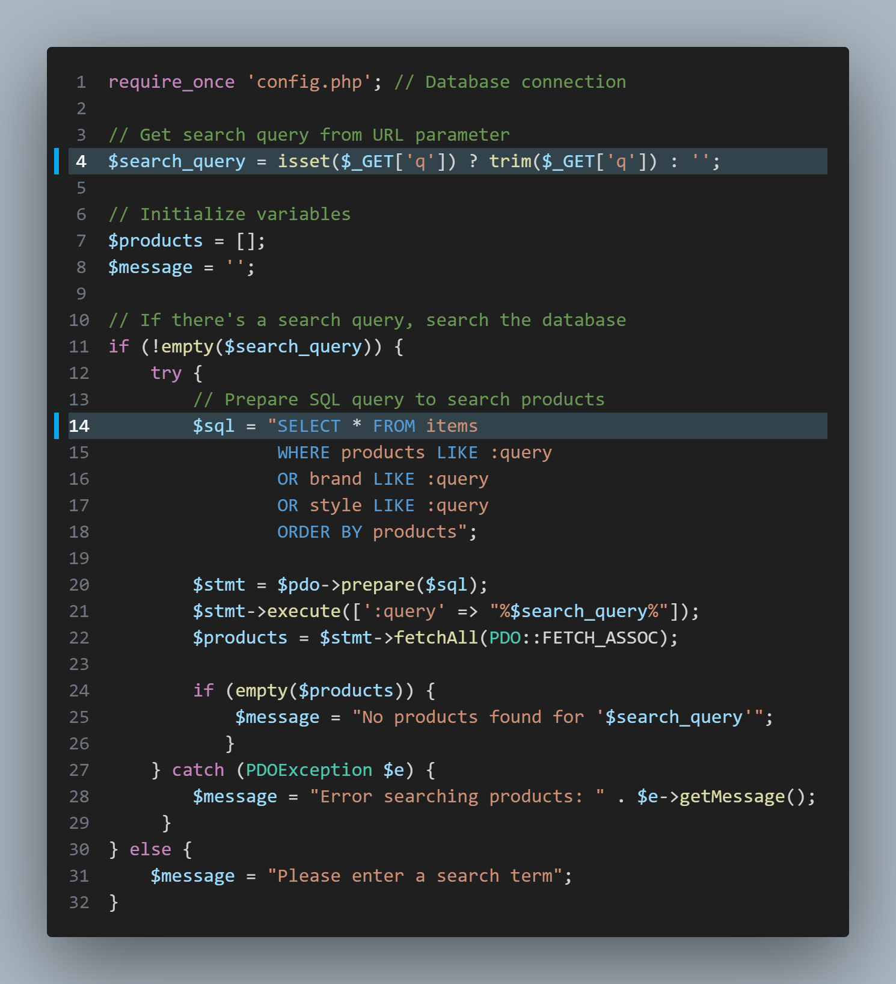

**Special Features:**

It is a function for finding the most suitable earphone for the users. Users have to answer few questions to find the most suitable earphone.

Effect:

Step 1

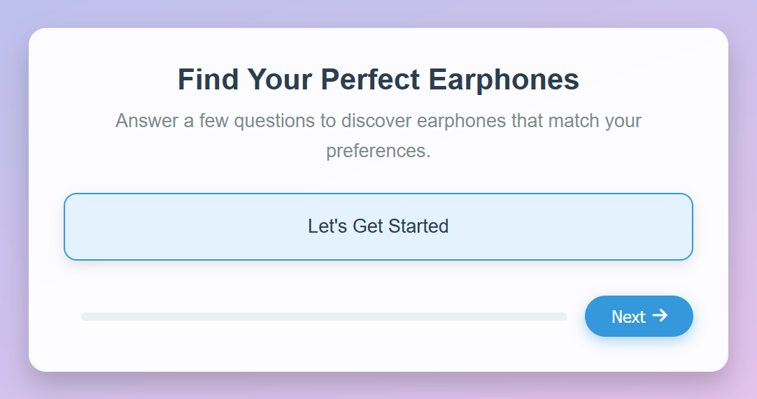

Step 2

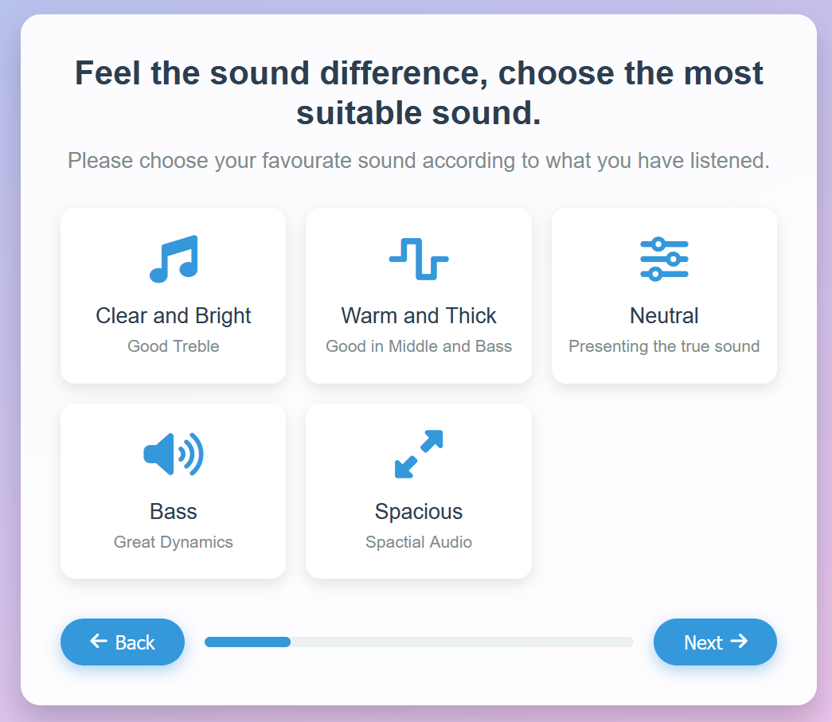

Step 3

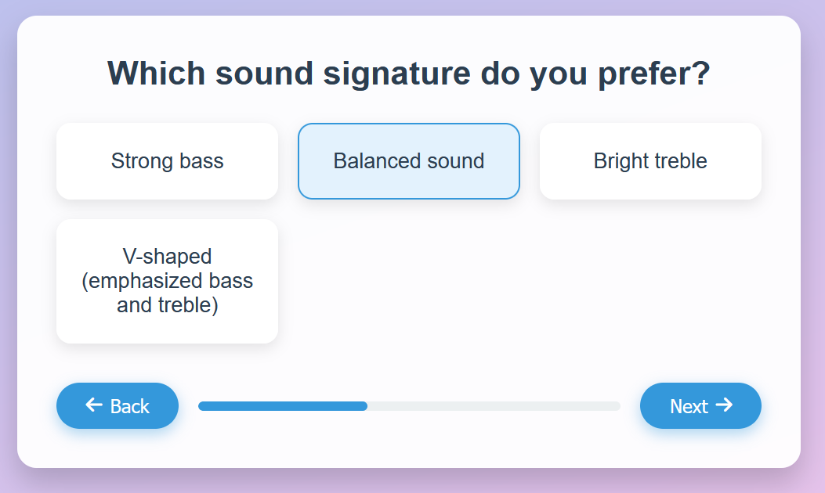

Step 4

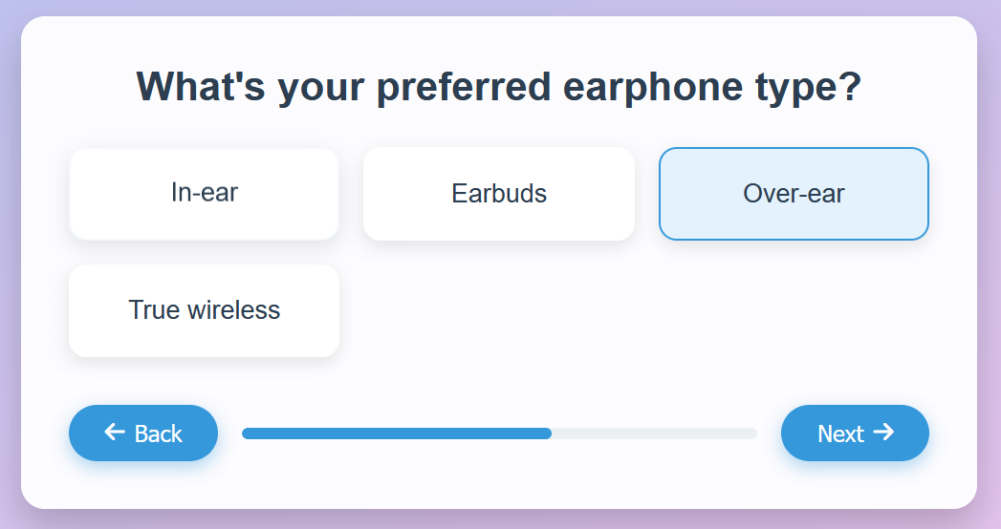

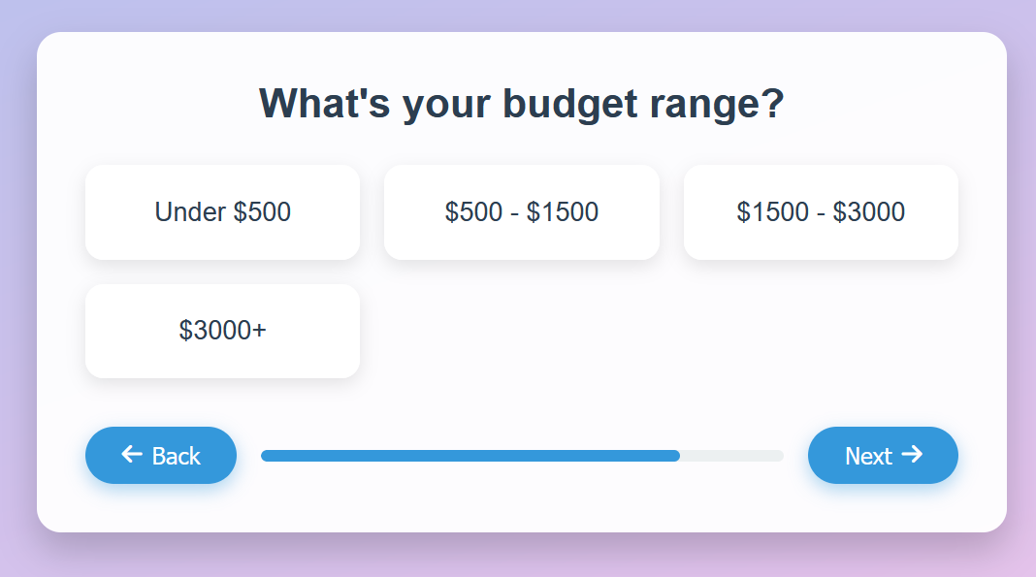Step 5

Step 6

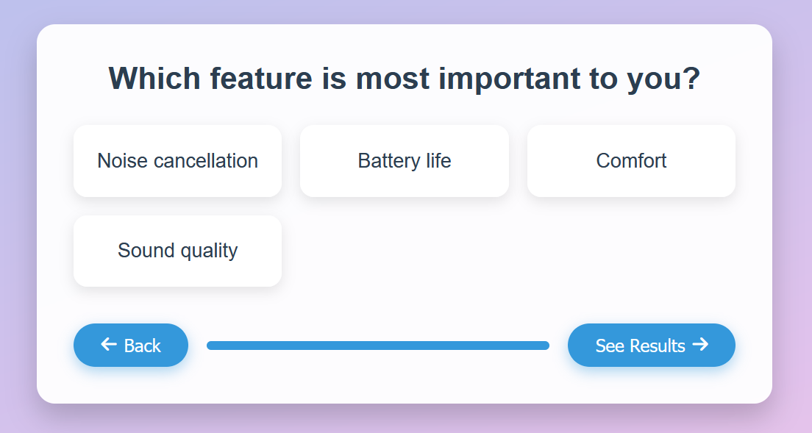

Step 7

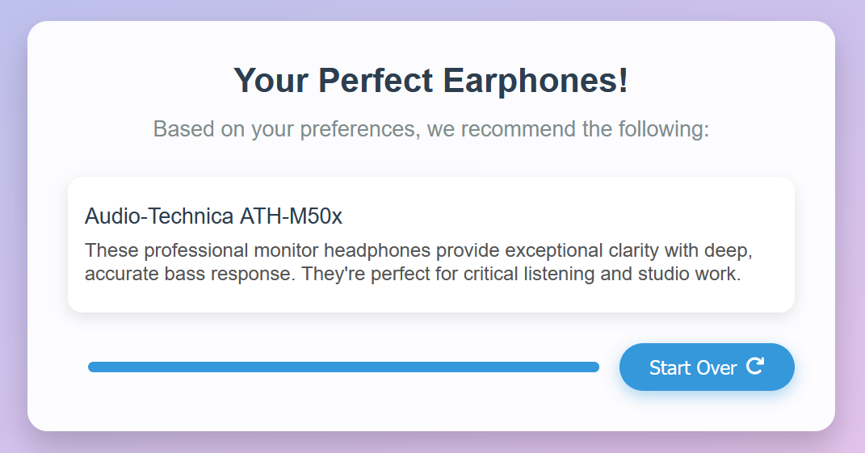

If there are no options chosen, the server will alert that after pressing the next button.

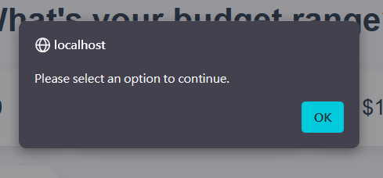

Code:

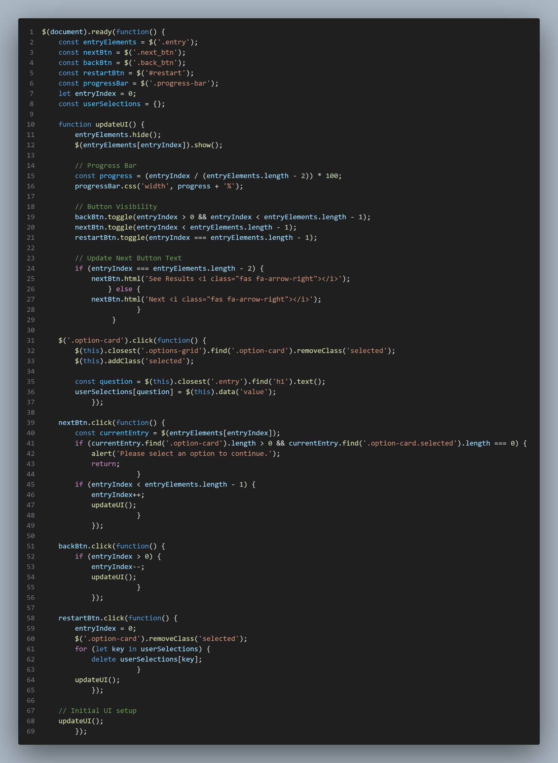

**Website Consistency**

Print-friendly version

There is print function for the order history of customers and the admin page order history overview.